# GyroScope PointOfSale Test Plan

## Test #1 Adding and Customizing VirgoClassicGyro

1. Fire up the application. You should see a window like this:

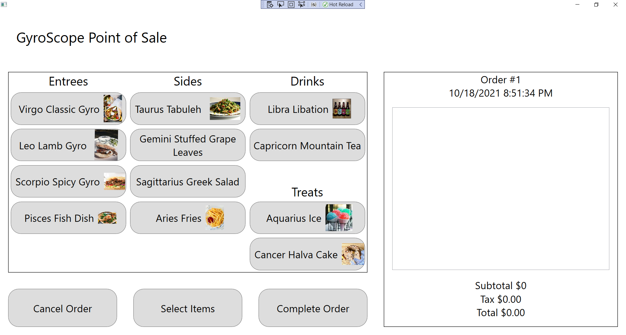

1. Click on Virgo Classic Gyro:

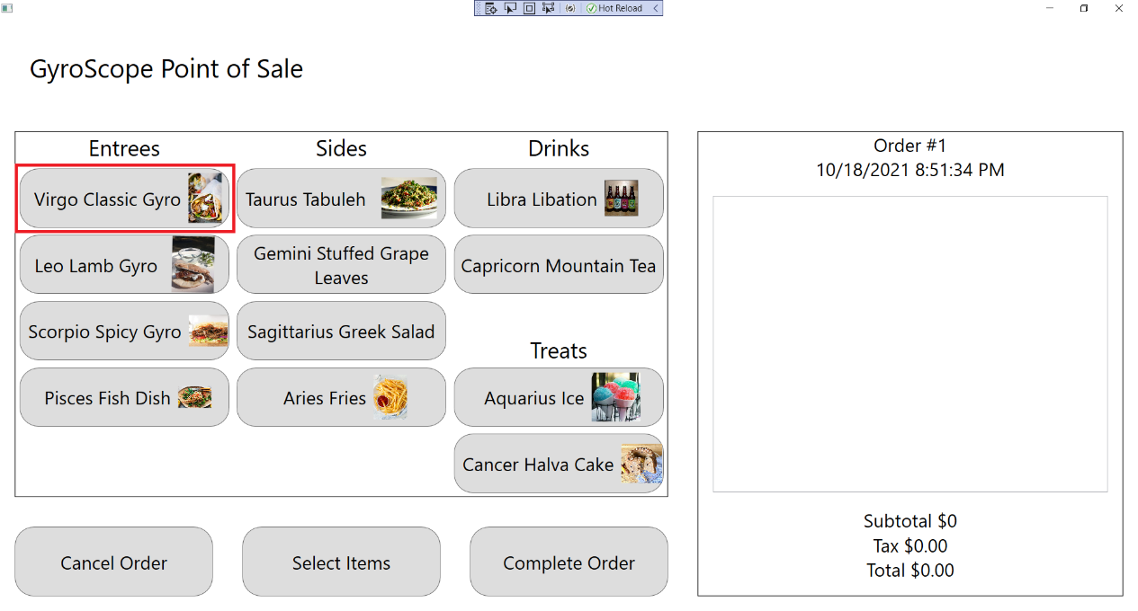

1. The customization screen should appear and a Virgo Classic Gyro should be added to the order, with Order #1, $5.50 Subtotal, $.50 Tax and $6.00 Total being displayed:

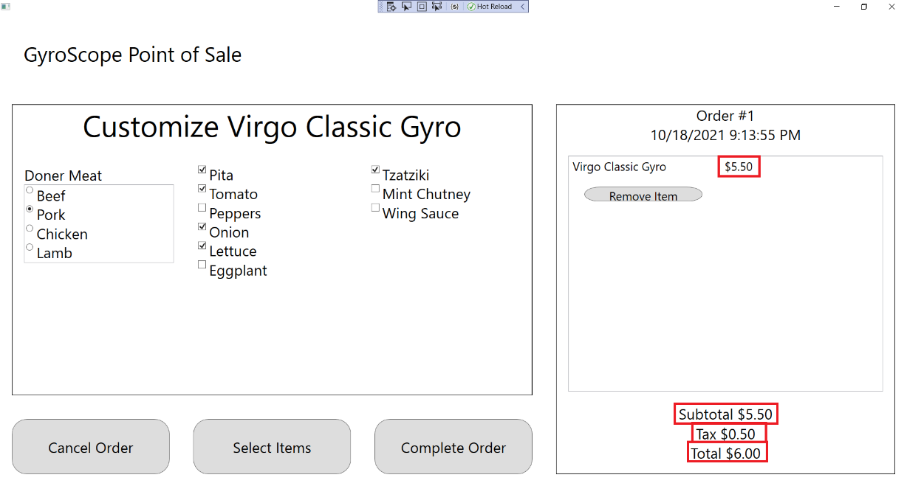

1. Change Doner Meat to Beef, Chicken, or Lamb, and “Use Beef”, “Use Chicken”, or “Use Lamb” should be displayed under the menu item:

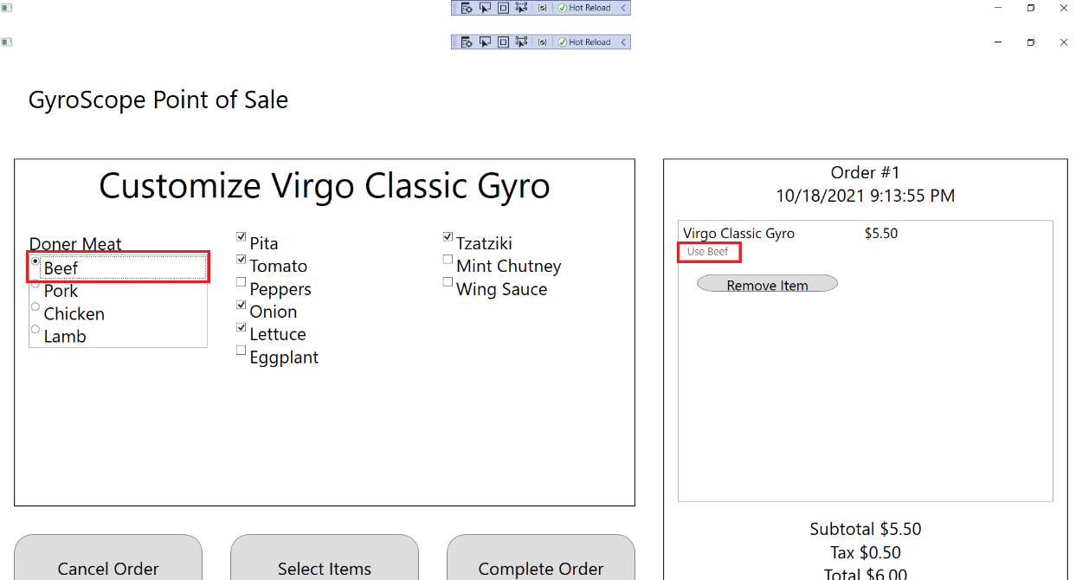

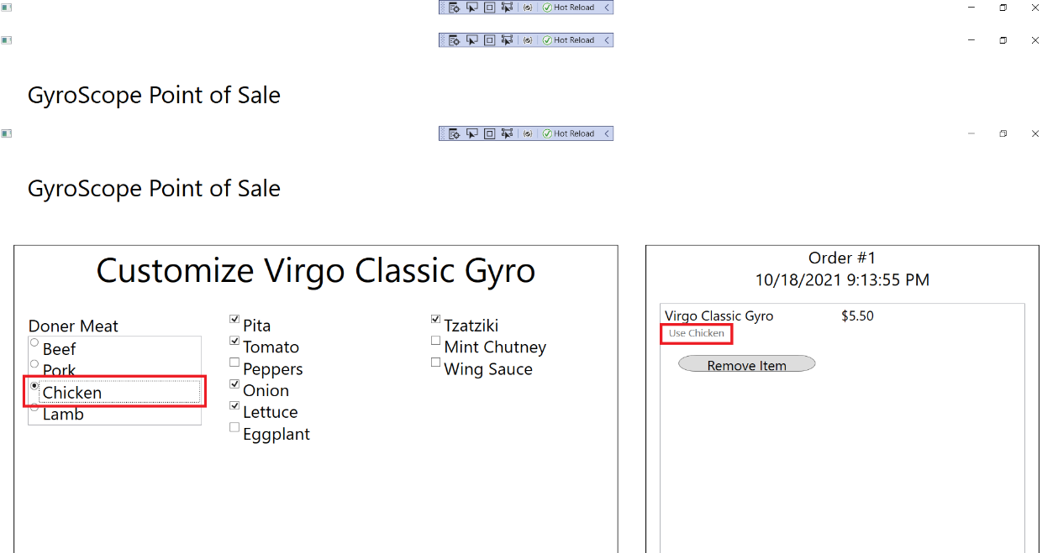

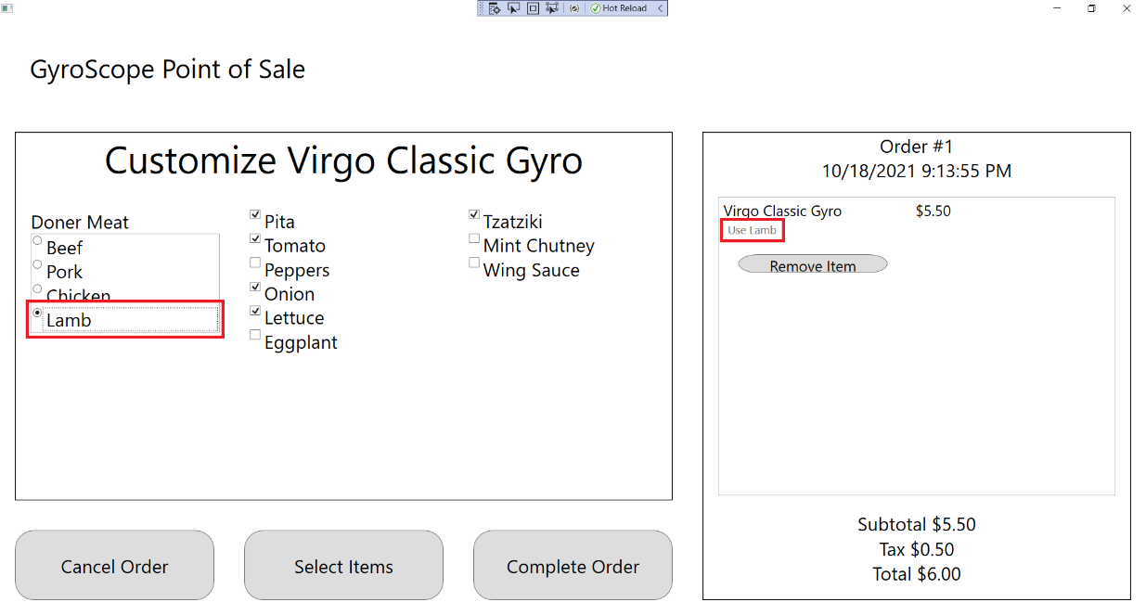

1. Uncheck Pita, Tomato, Onion, Lettuce, and Tzatziki. All unchecked items should show up underneath the menu item as “hold [item]”:

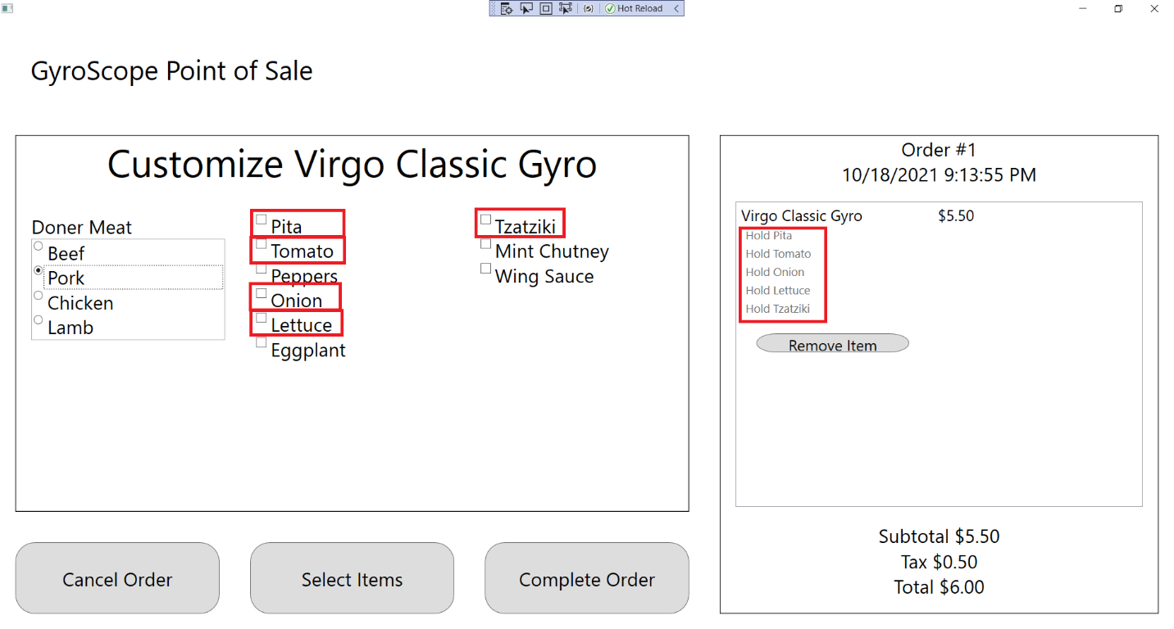

1. Check all boxes. All added items should show up underneath the menu item as “Add [item]”

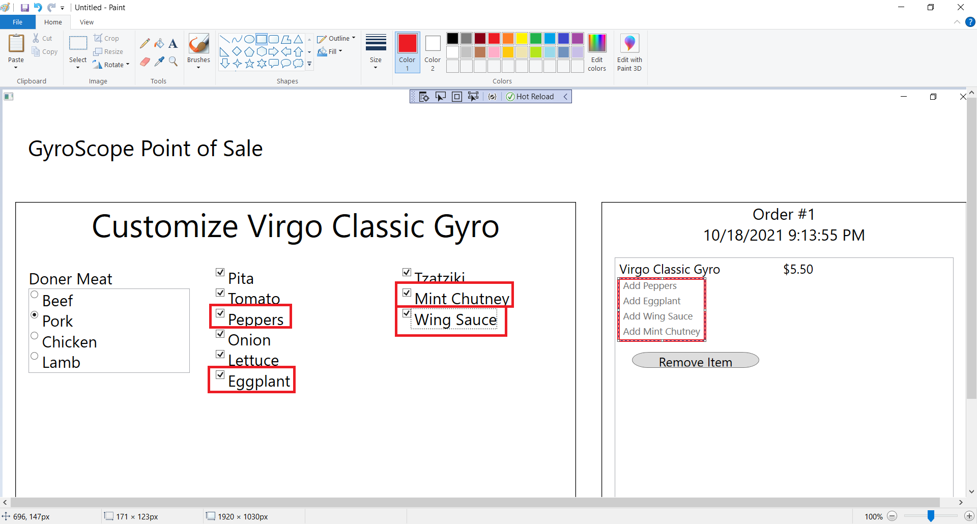

## Test #2 Adding and Customizing LeoLambGyro

1. Click on Leo Lamb Gyro:

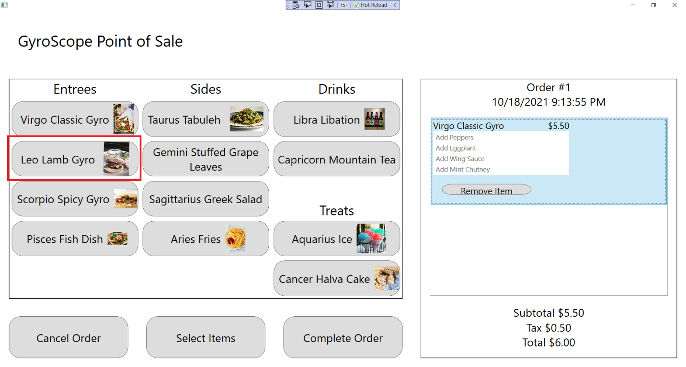

1. The customization screen should appear and a Leo Lamb Gyro should be added to the order, with Order #1, $5.75 Subtotal, $.52 Tax and $6.27 Total being displayed:

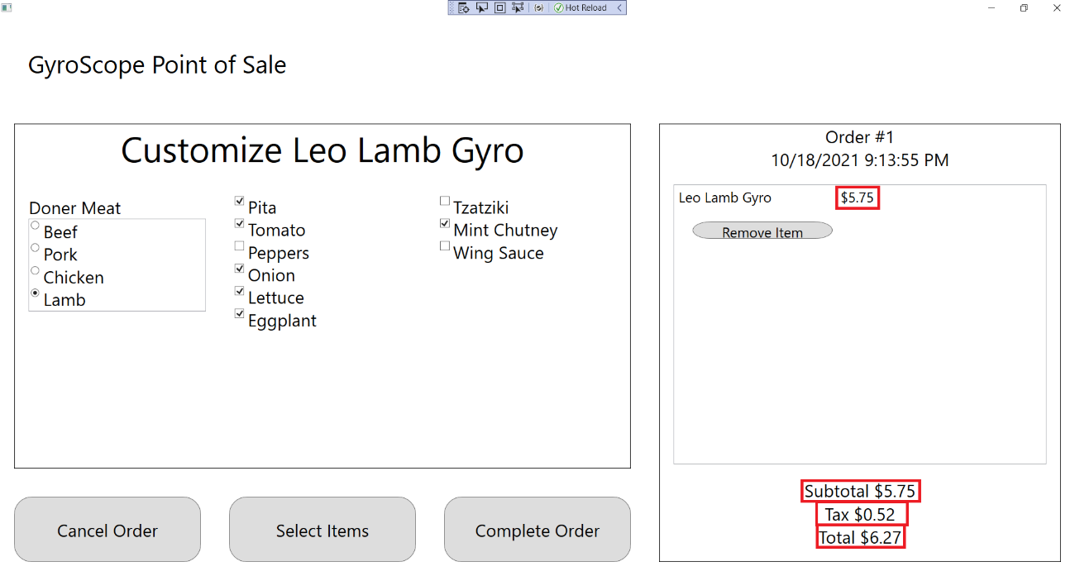

1. Change Doner Meat to Beef, Chicken, or Pork, and “Use Beef”, “Use Chicken”, or “Use Pork” should be displayed under the menu item:

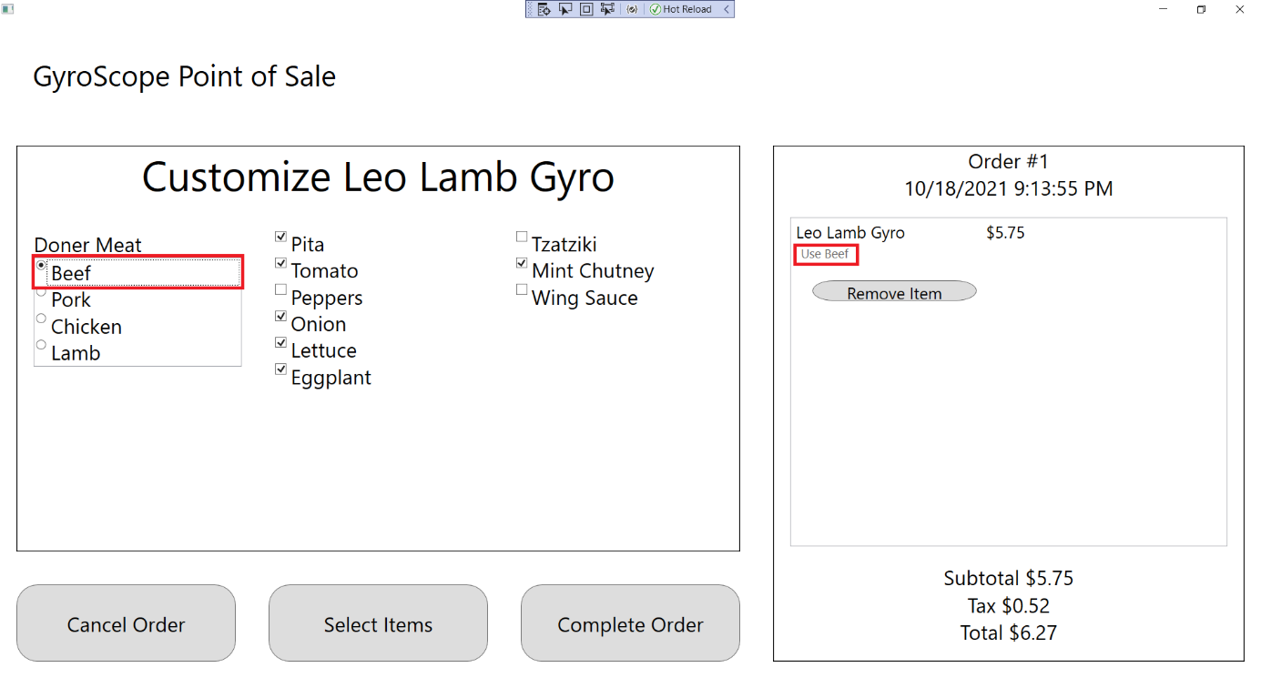

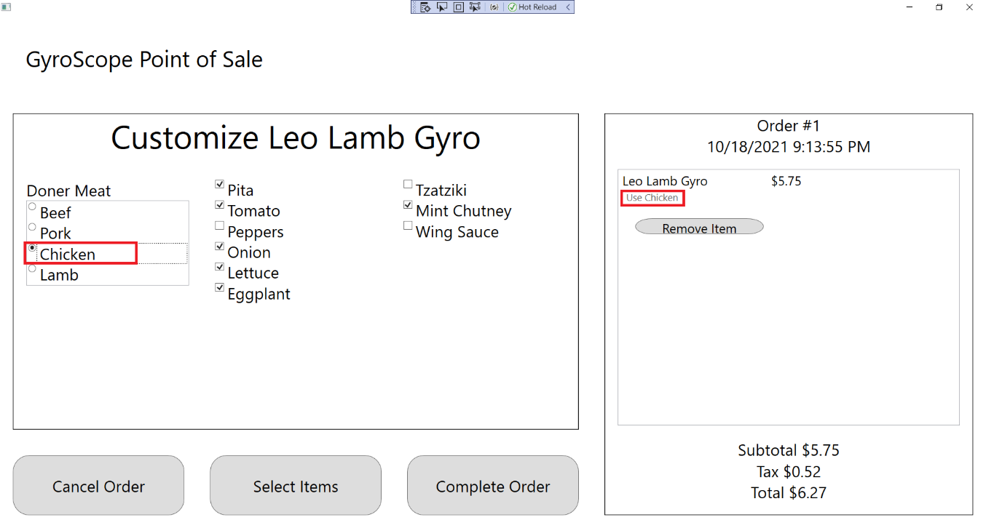

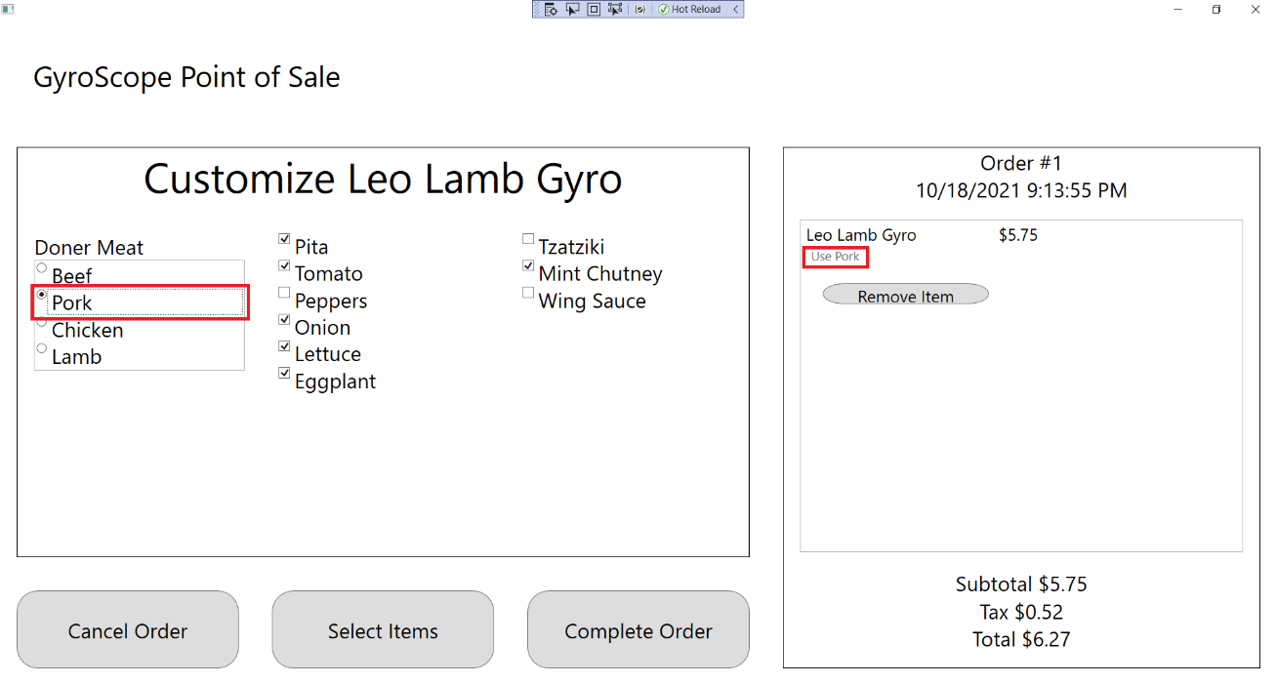

1. Uncheck Pita, Tomato, Onion, Lettuce, Eggplant and Mint Chutney. All unchecked items should show up underneath the menu item as “hold [item]”:

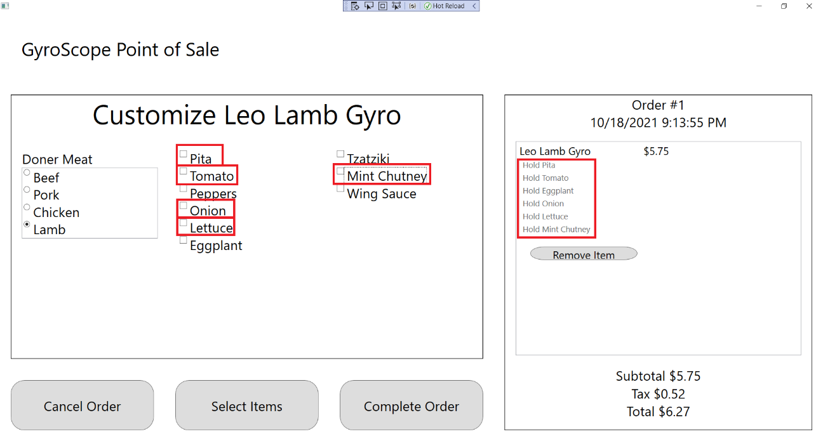

1. Check all boxes. All added items should show up underneath the menu item as “Add [item]”

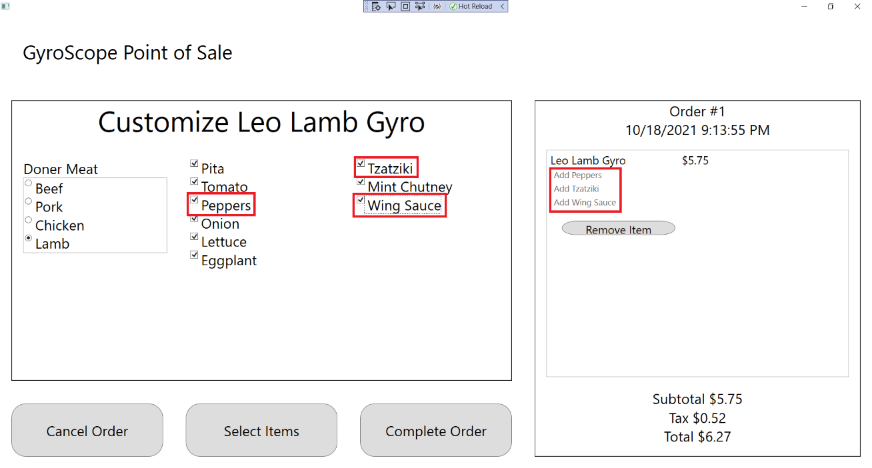

## Test #3 Adding and Customizing ScorpioSpicyGyro

1. Click on Scorpio Spicy Gyro:

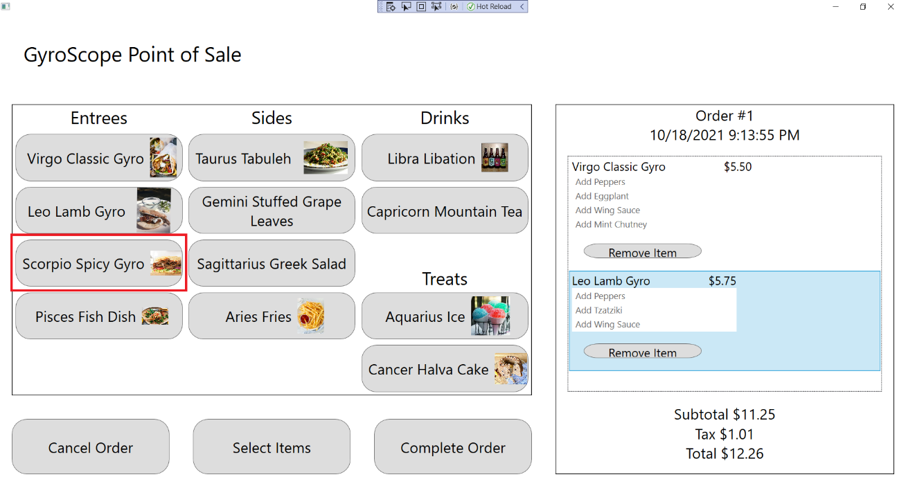

1. The customization screen should appear and a Leo Lamb Gyro should be added to the order, with Order #1, $6.20 Price, $17.45 Subtotal, $1.57 Tax and $19.02 Total being displayed:

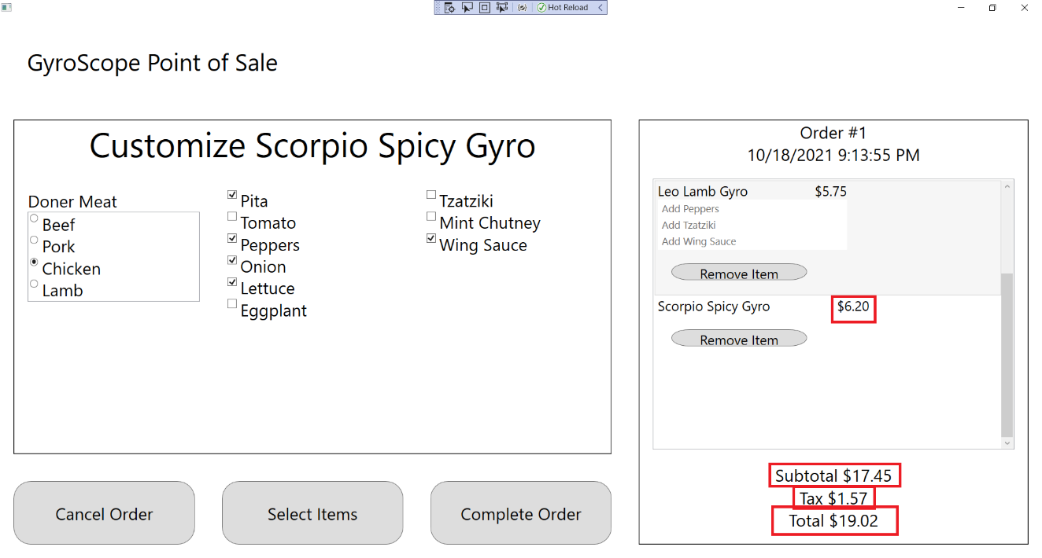

1. Change Doner Meat to Beef, Lamb, or Pork, and “Use Beef”, “Use Lamb”, or “Use Pork” should be displayed under the menu item:

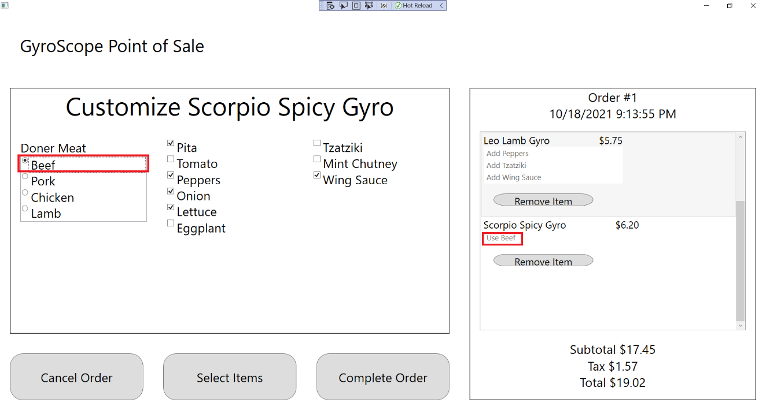

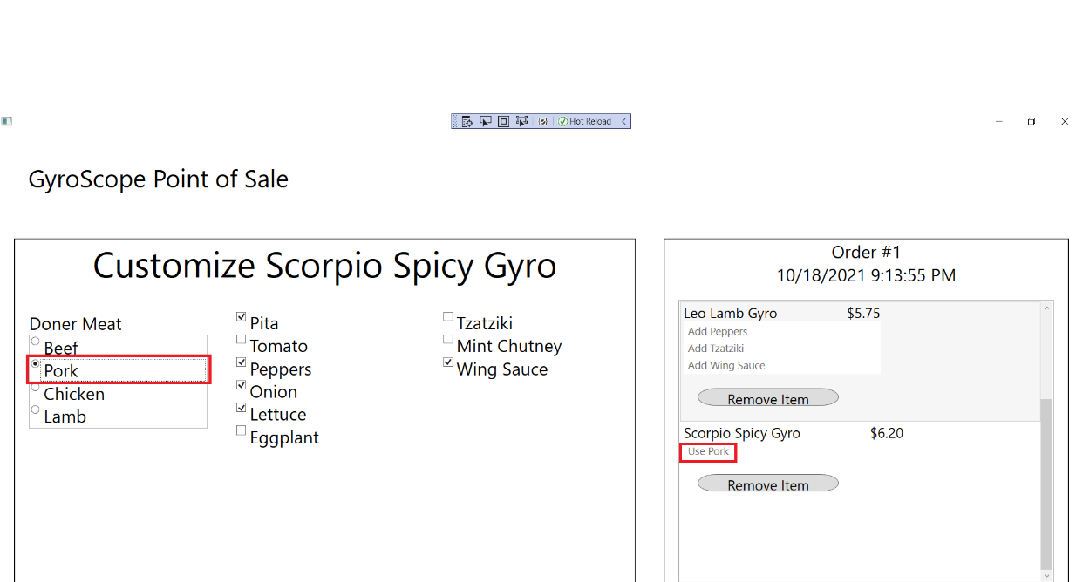

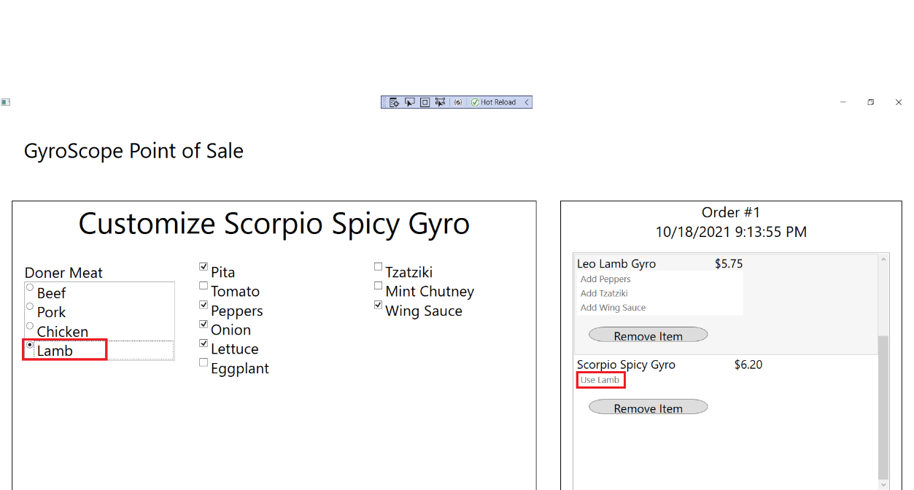

1. Uncheck Pita, Peppers, Onion, Lettuce, and Wing Sauce. All unchecked items should show up underneath the menu item as “hold [item]”:

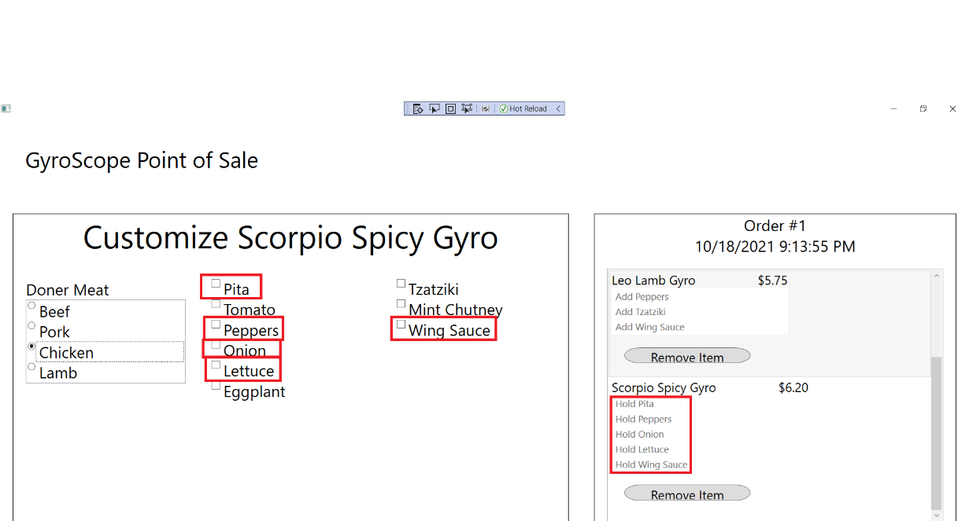

1. Check all boxes. All added items should show up underneath the menu item as “Add [item]”

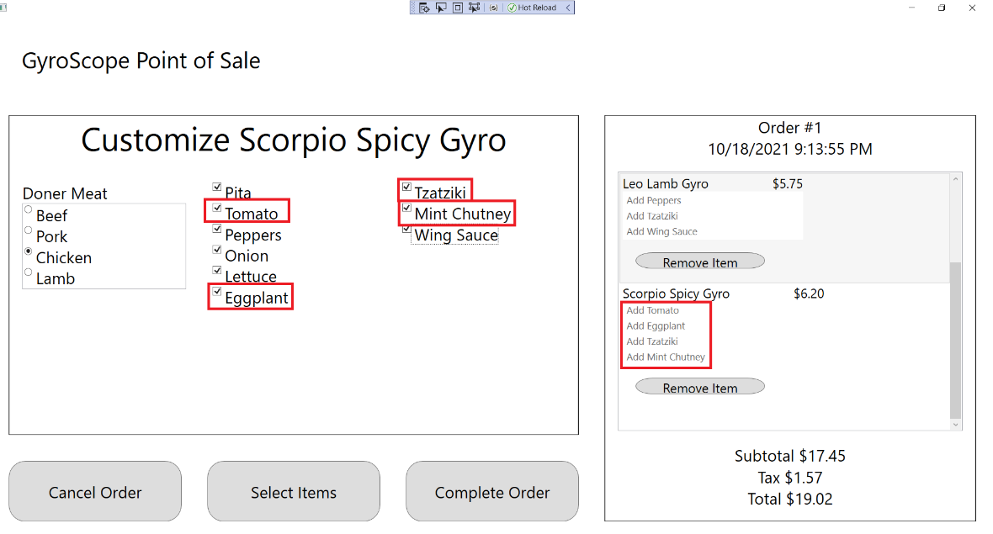

## Test #4 Adding and Customizing PiscesFishDish

1. Click on Pisces Fish Dish:

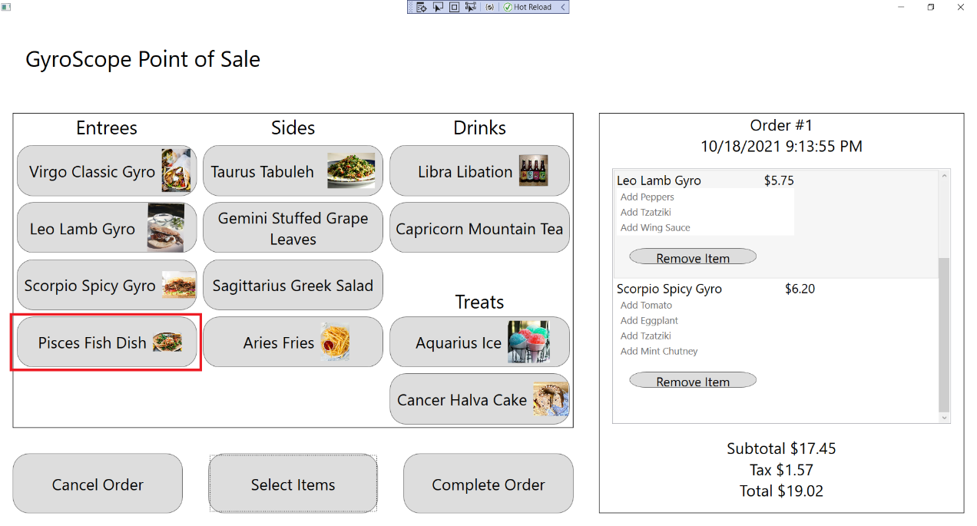

1. The customization screen should appear and a Pisces Fish Dish should be added to the order, with Order #1, $5.99 Price, $23.44 Subtotal, $2.11 Tax and $25.55 Total being displayed:

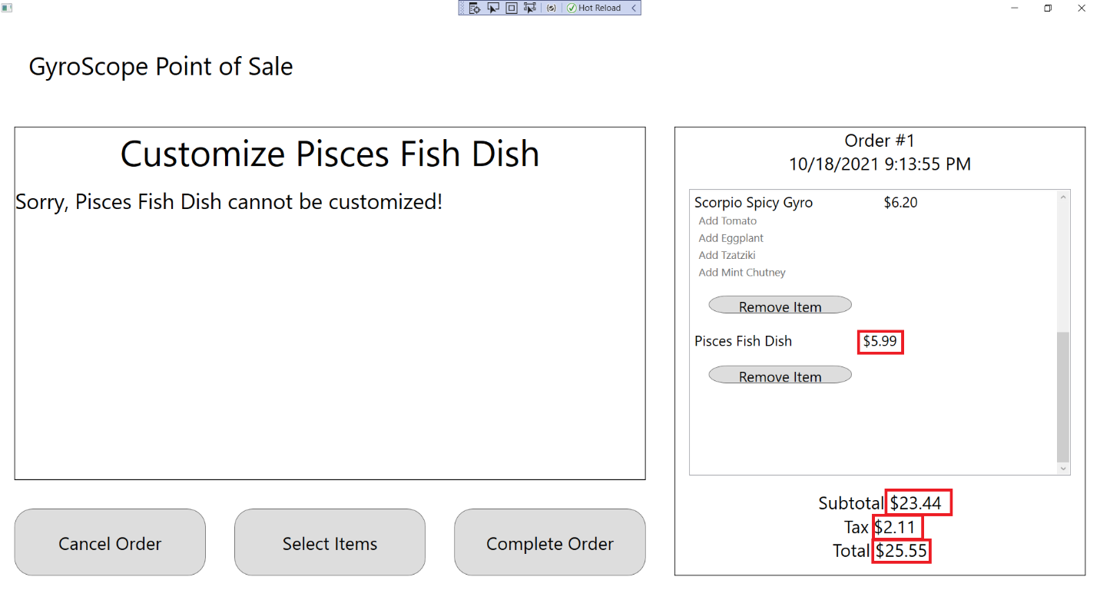

1. Press the “Select Items” button to return to the Menu Item Selection screen:

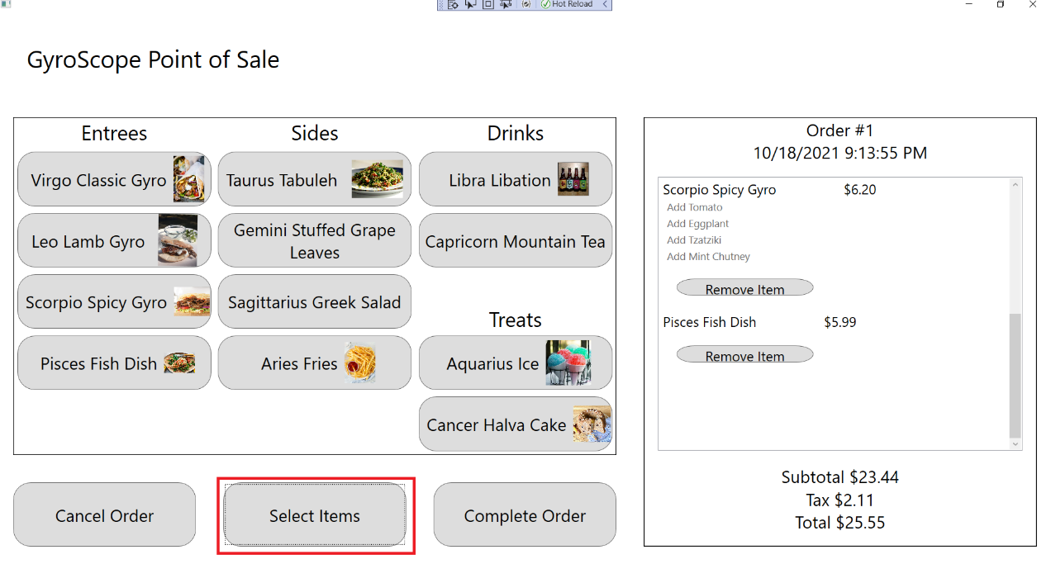

## Test #5 Adding and Customizing TaurusTabuleh

1. Click on Taurus Tabuleh:

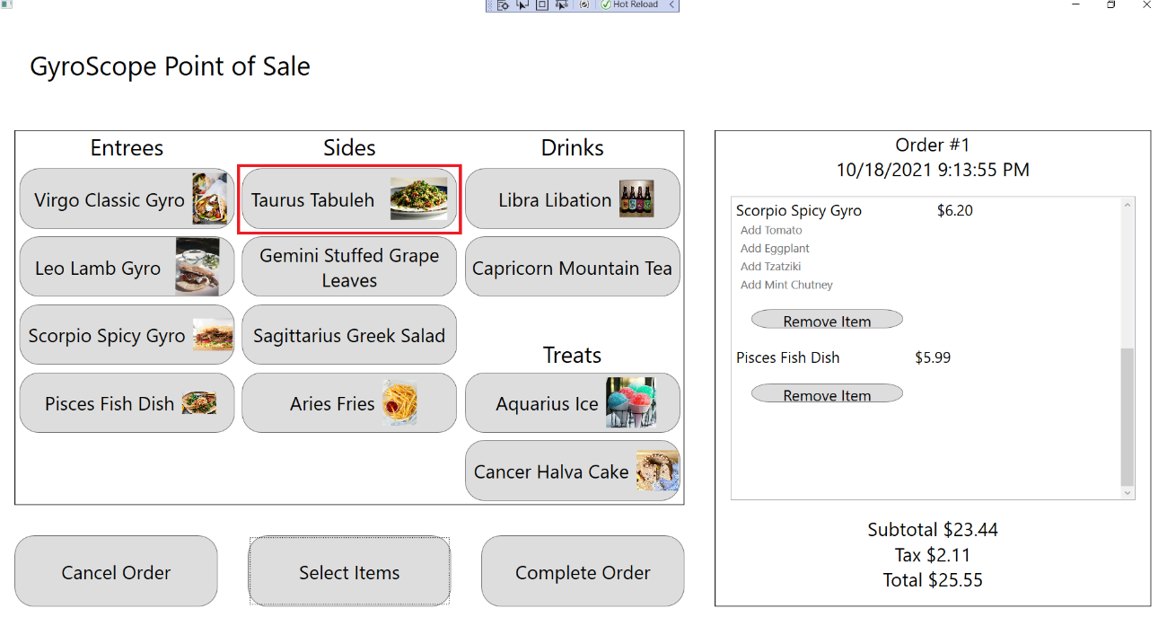

1. The customization screen should appear and a Taurus Tabuleh should be added to the order, with Order #1, $1.50 Price, $24.94 Subtotal, $2.24 Tax and $27.18 Total being displayed:

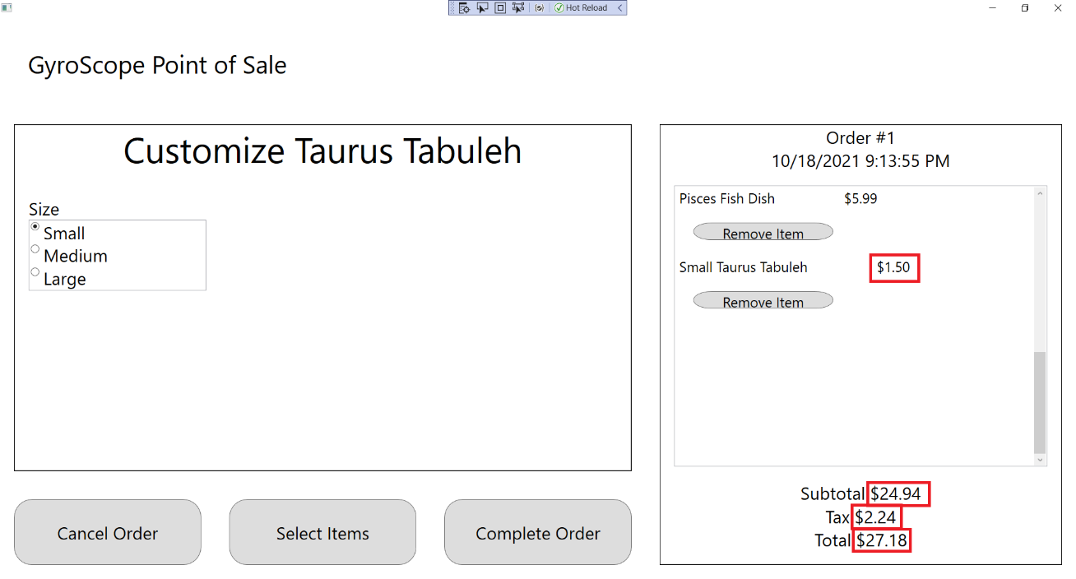

1. Change Size to Small, Medium, and Large. “Small”, “Medium, or “Large” should appear in front the Menu Item name, along with “$1.50”, $2.00”, and “$2.50”:

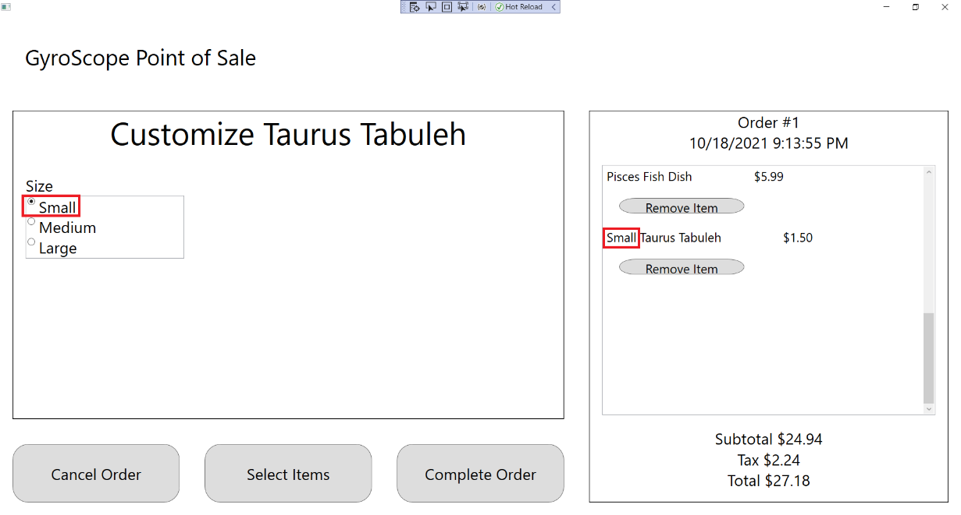

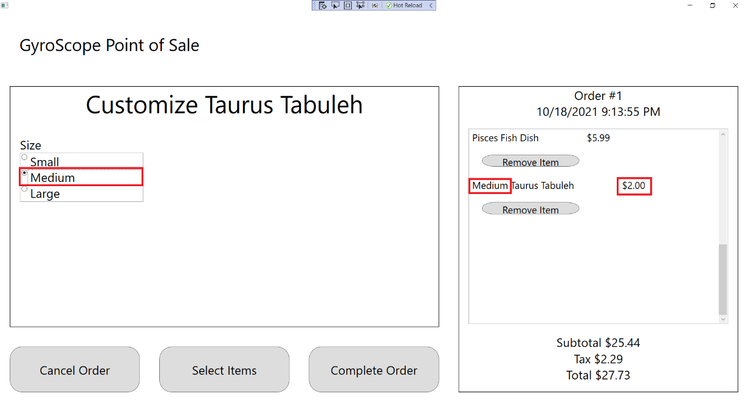

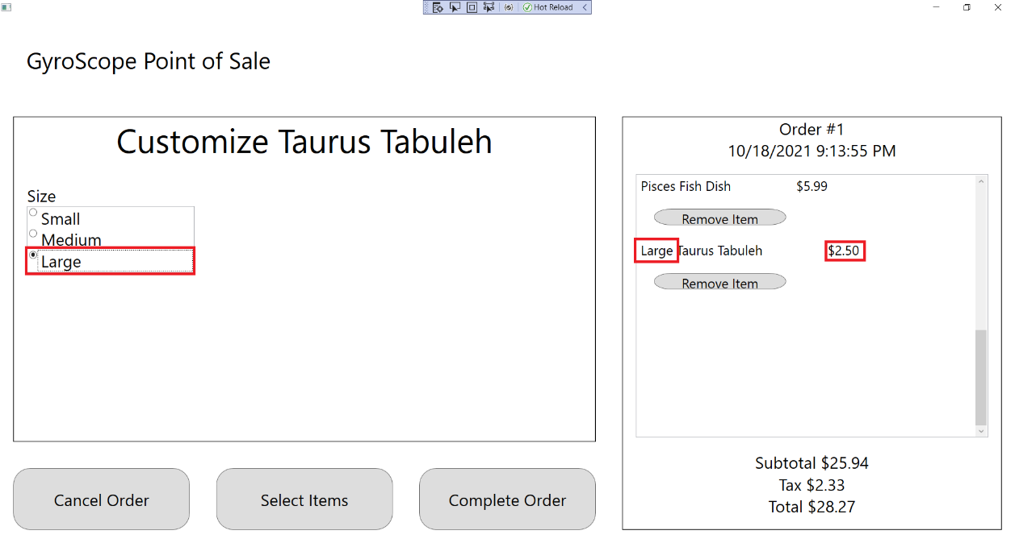

1. Press the “Select Items” button to return to the Menu Item Selection screen:

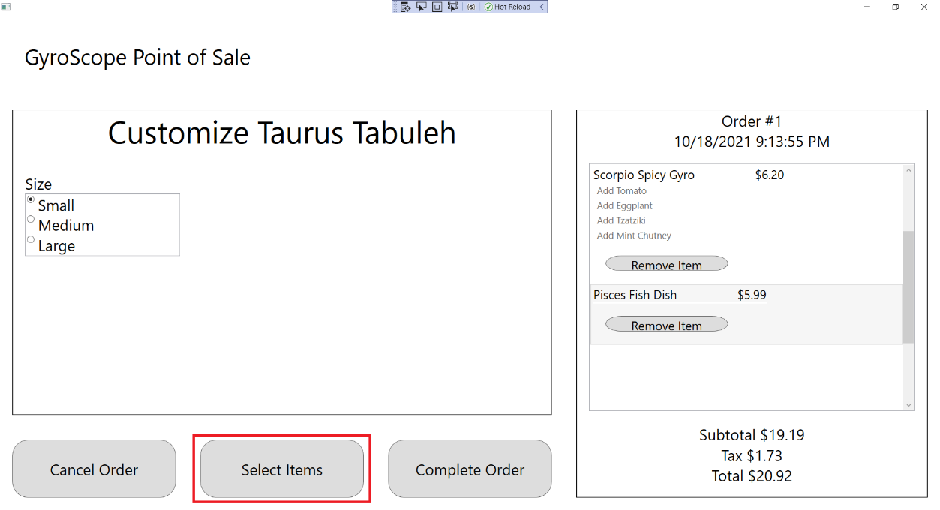

## Test #6 Adding and Customizing GeminiStuffedGrapeLeaves

1. Click on Gemini Stuffed Grape Leaves:

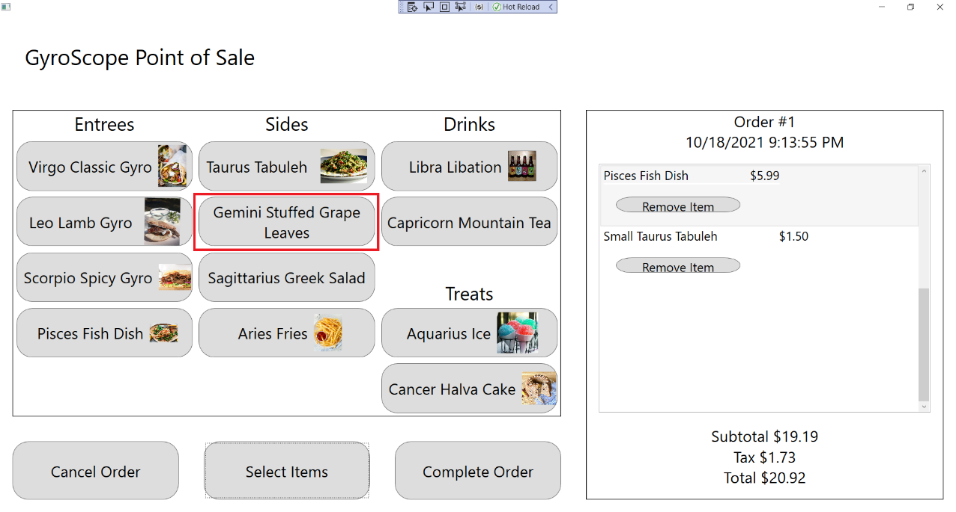

1. The customization screen should appear and a Pisces Fish Dish should be added to the order, with Order #1, $1.50 Price, $26.44 Subtotal, $2.38 Tax and $28.82 Total being displayed:

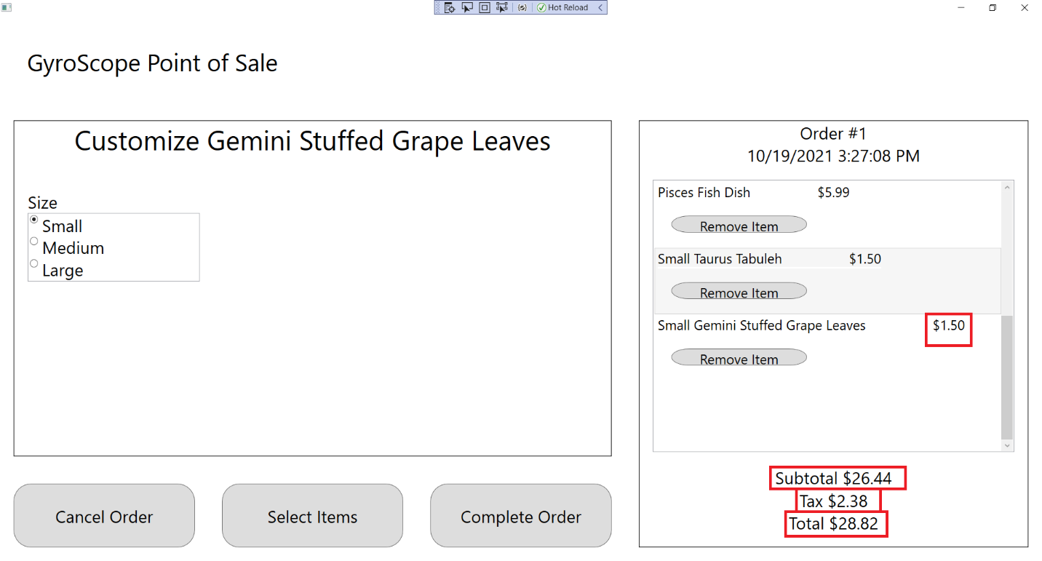

1. Change Size to Small, Medium, and Large. “Small”, “Medium, or “Large” should appear in front the Menu Item name, along with “$1.50”, $2.00”, and “$2.50”:

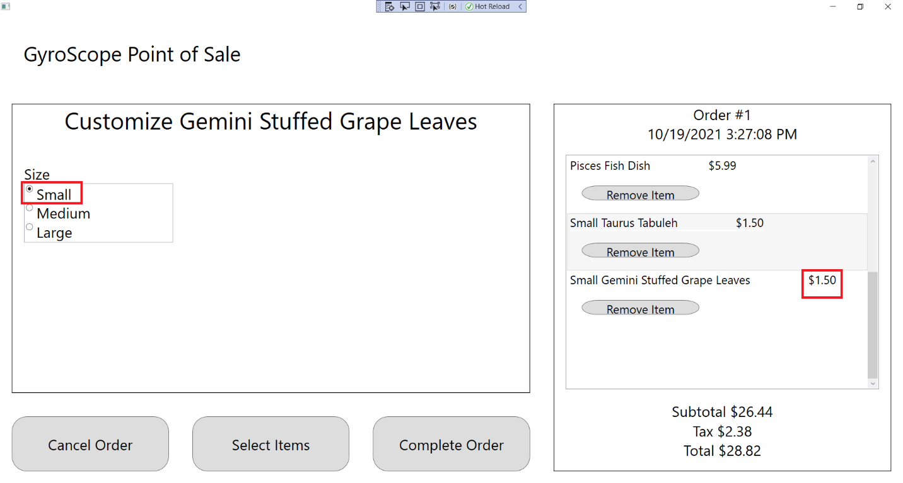

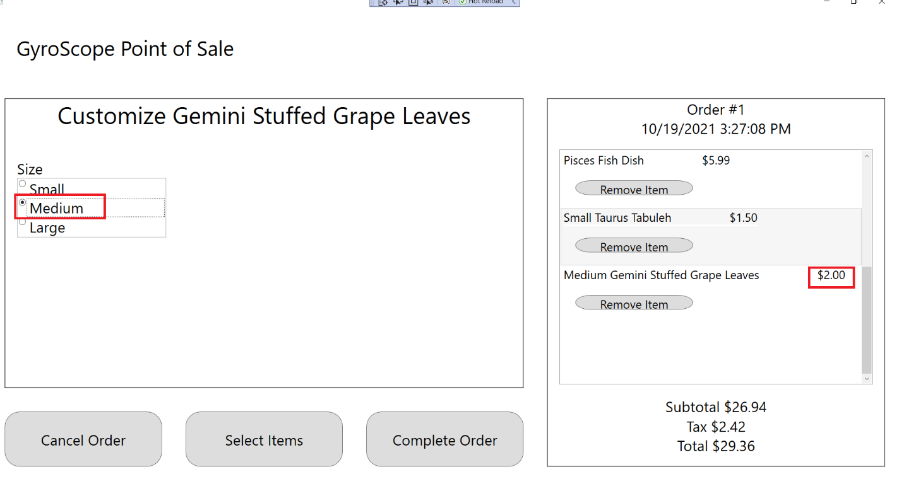

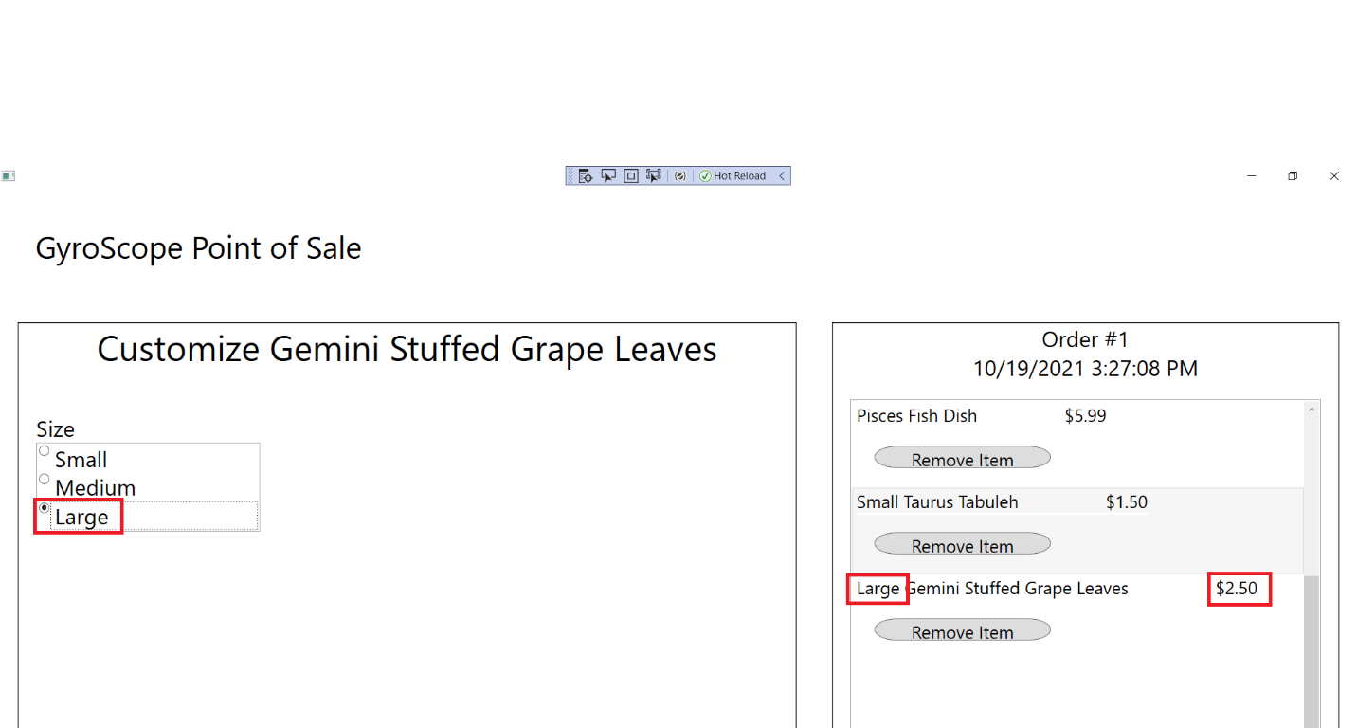

1. Press the “Select Items” button to return to the Menu Item Selection screen:

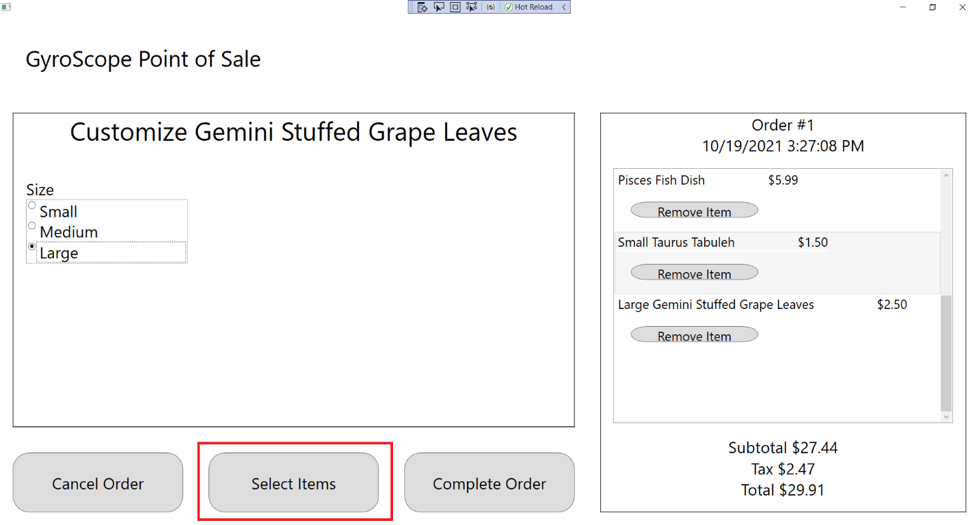

## Test #7 Adding and Customizing SagittariusGreekSalad

1. Click on Sagittarius Greek Salad:

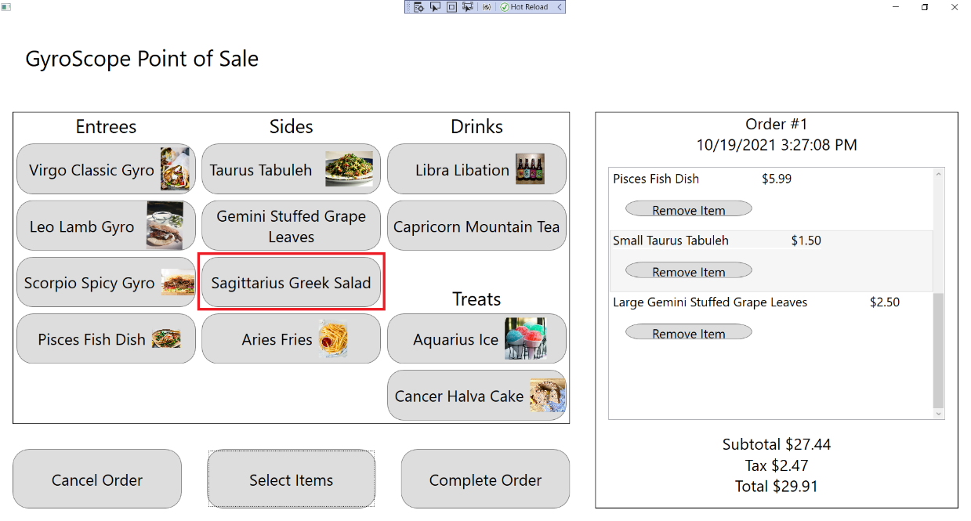

1. The customization screen should appear and a Sagittarius Greek Salad should be added to the order, with Order #1, $2.00 Price, $29.44 Subtotal, $2.65 Tax and $32.09 Total being displayed:

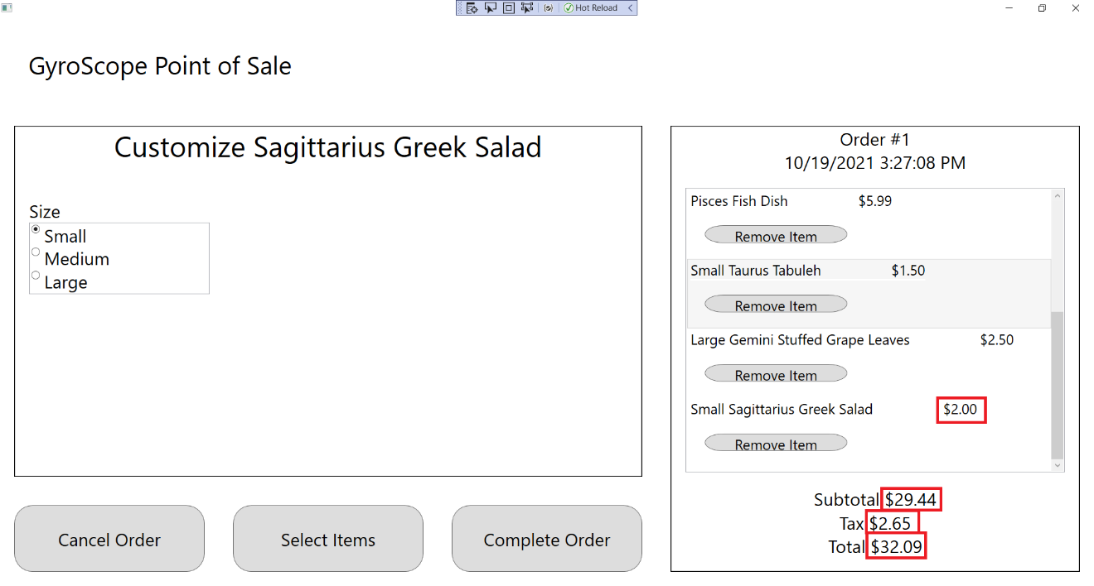

1. Change Size to Small, Medium, and Large. “Small”, “Medium, or “Large” should appear in front the Menu Item name, along with “$2.00”, $2.50”, and “$3.00”:

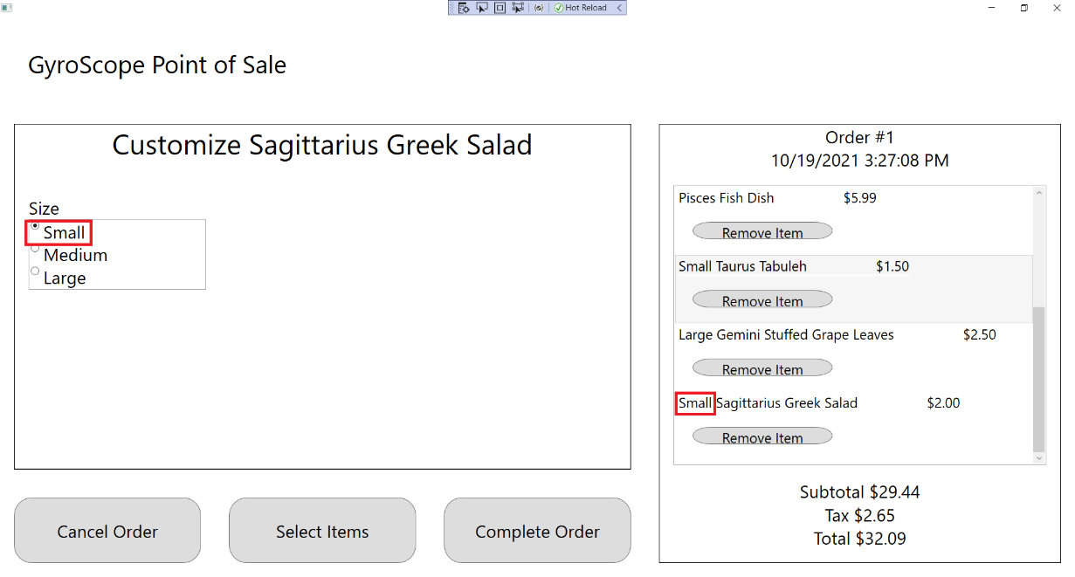

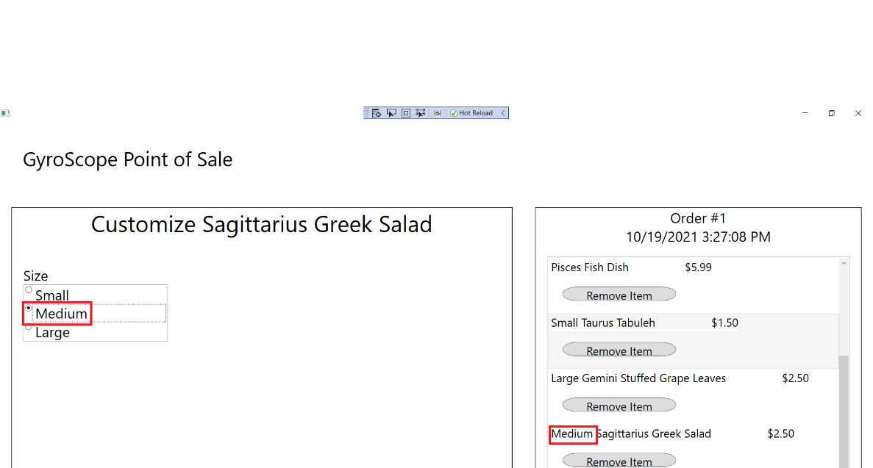

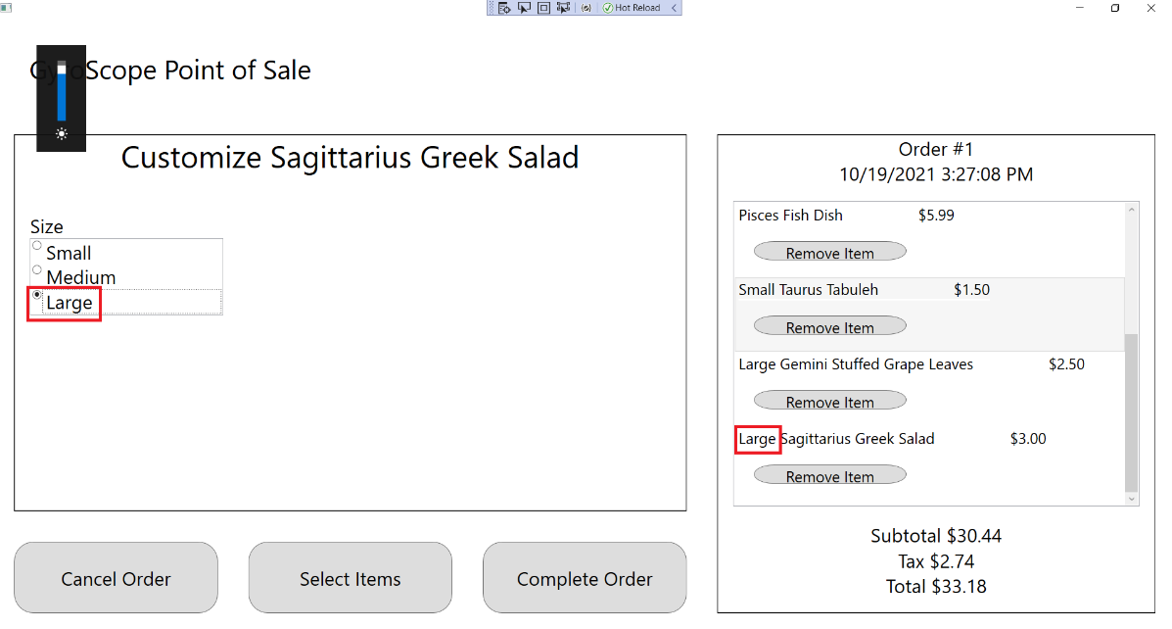

1. Press the “Select Items” button to return to the Menu Item Selection screen:

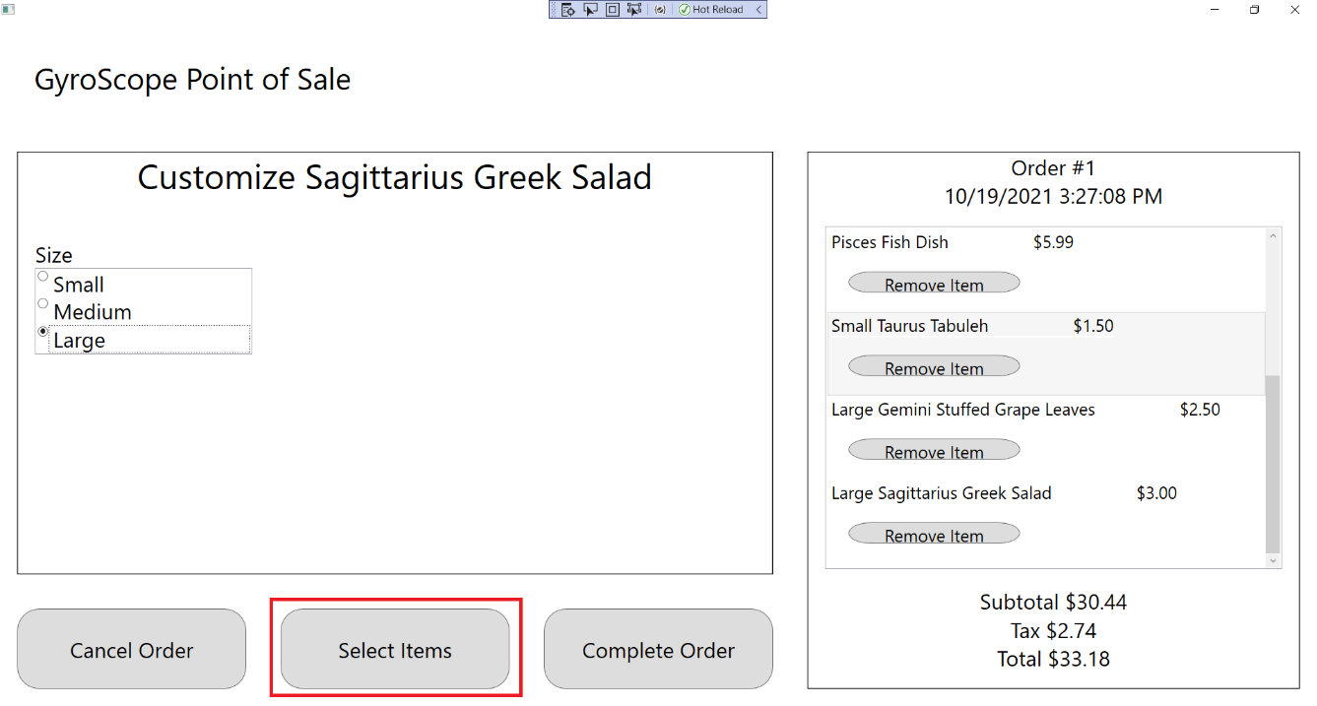

## Test #8 Adding and Customizing AriesFries

1. Click on Aries Fries:

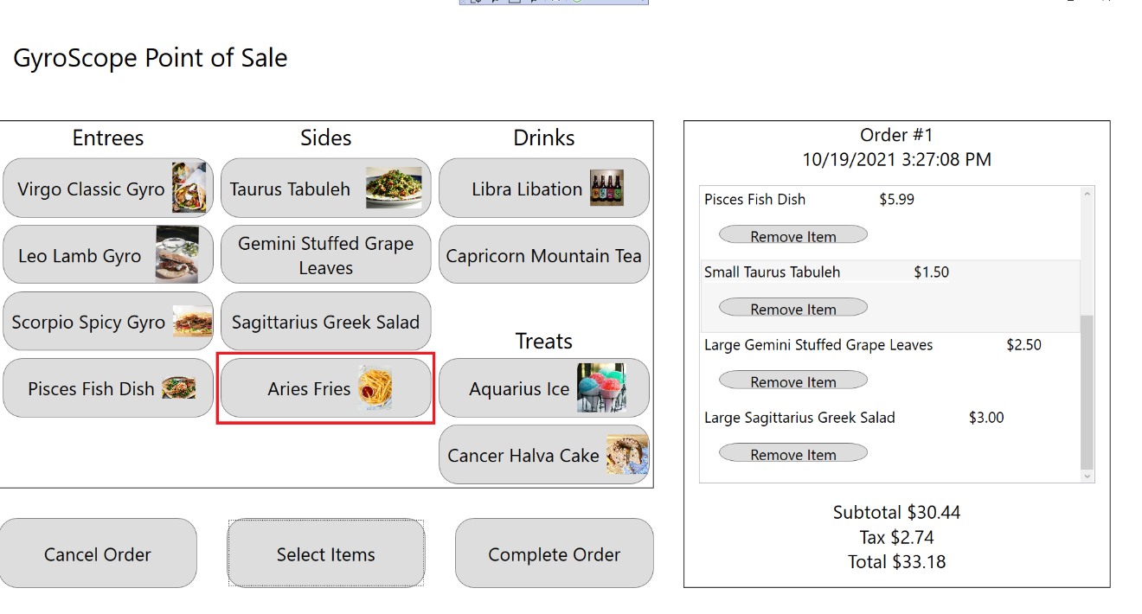

1. The customization screen should appear and a Aries Fries should be added to the order, with Order #1, $3.00 Price, $31.94 Subtotal, $2.87 Tax and $34.81 Total being displayed:

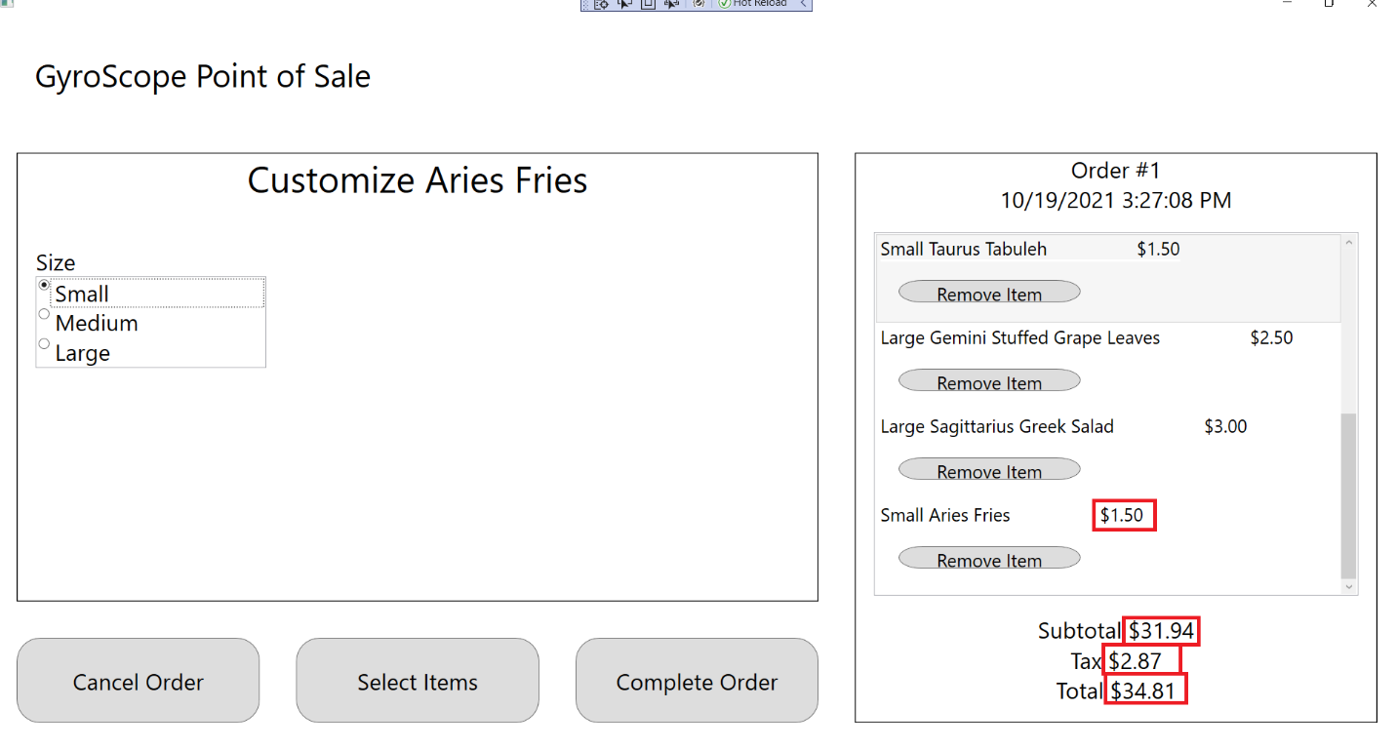

1. Change Size to Small, Medium, and Large. “Small”, “Medium, or “Large” should appear in front the Menu Item name, along with “$1.50”, $2.00”, and “$2.50”:

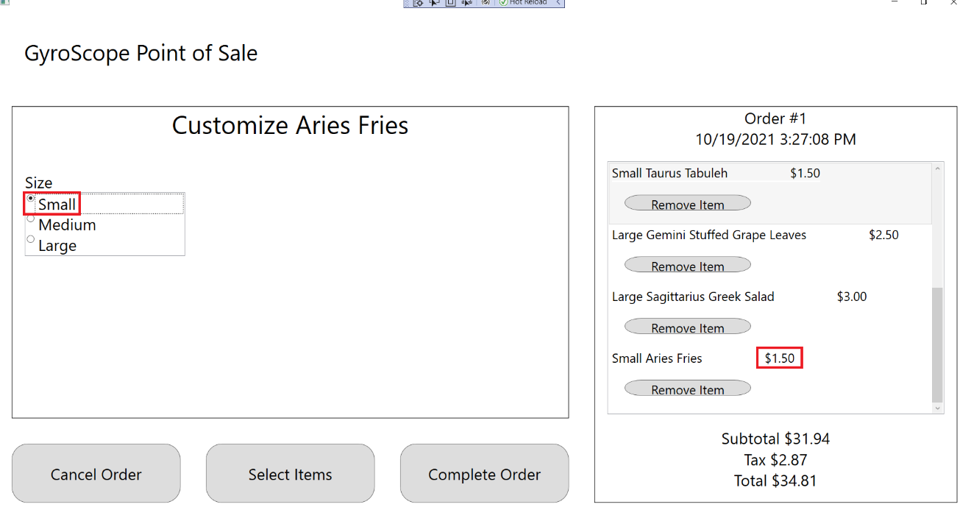

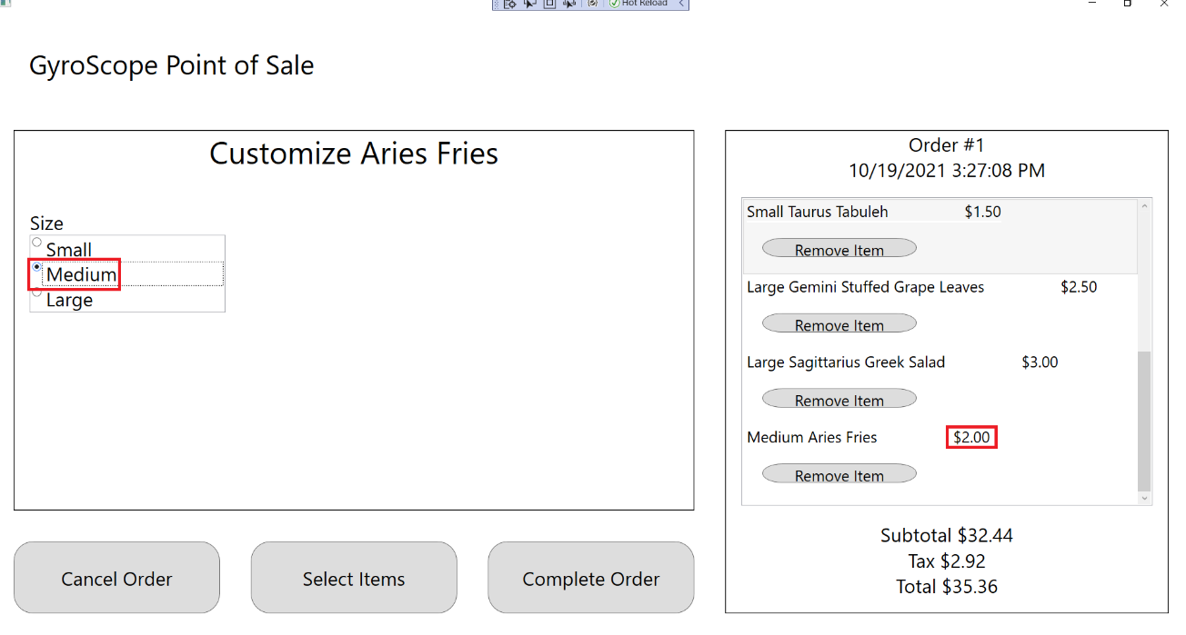

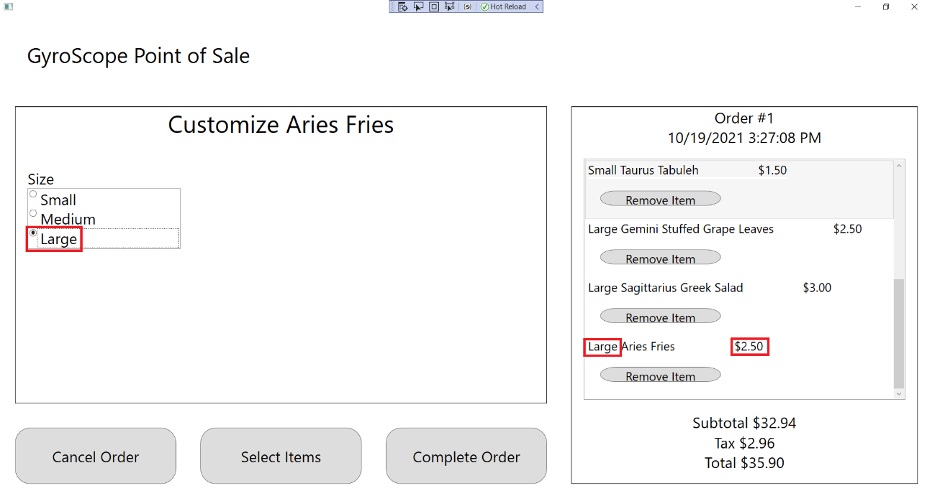

1. Press the “Select Items” button to return to the Menu Item Selection screen:

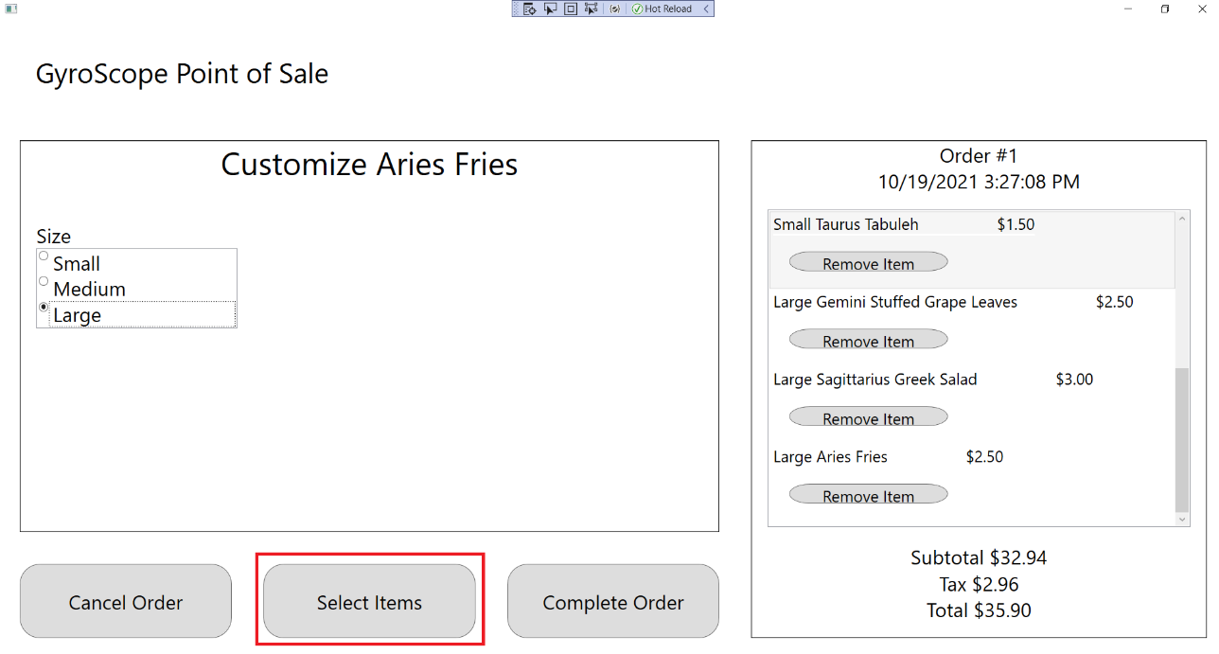

## Test #9 Adding and Customizing LibraLibation

1. Click on Libra Libation:

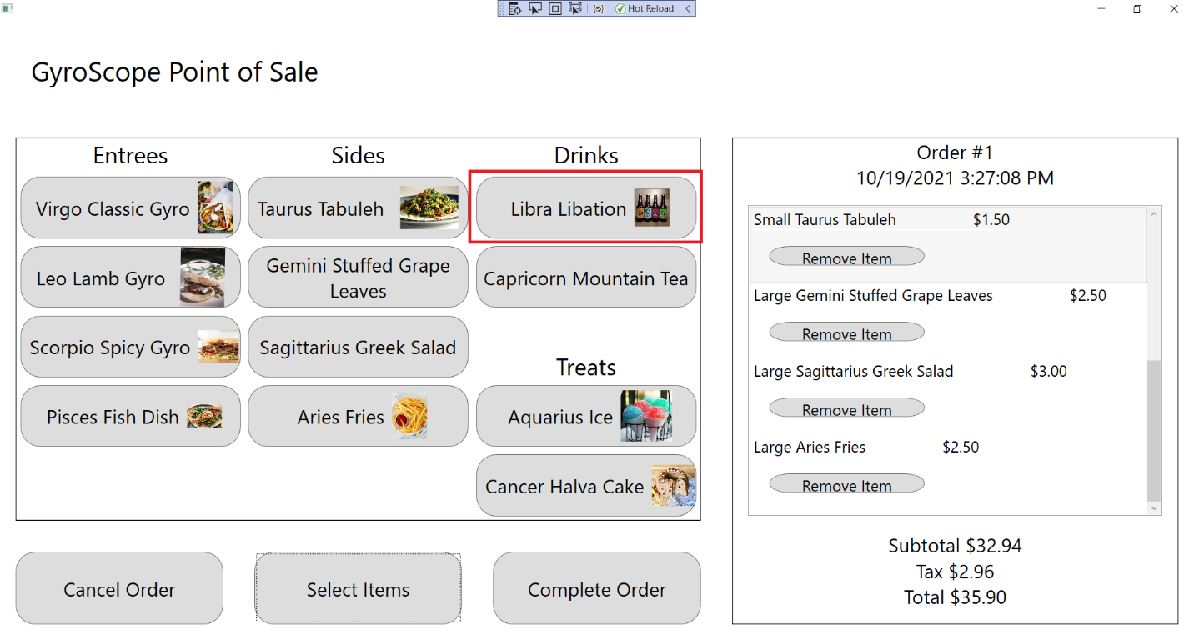

1. The customization screen should appear and a Libra Libation should be added to the order, with Order #1, $1.00 Price, $33.94 Subtotal, $3.05 Tax and $36.99 Total being displayed:

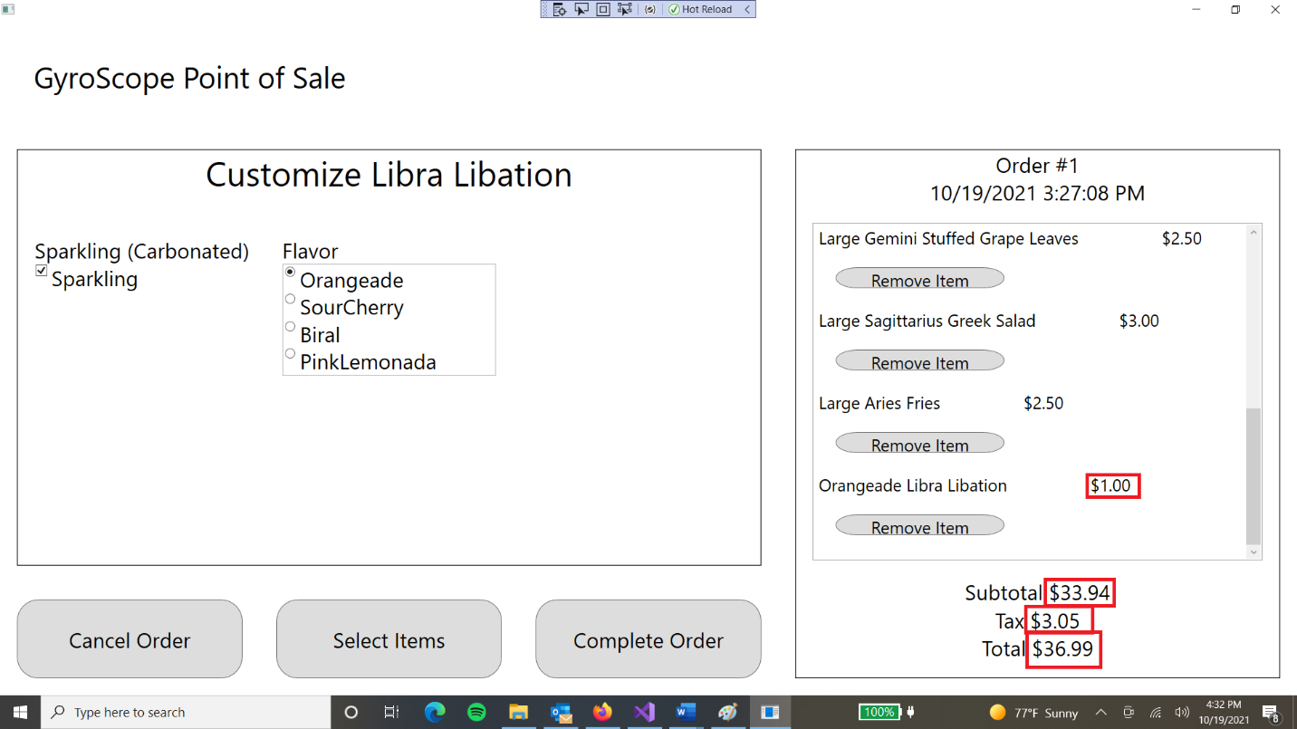

1. Uncheck the “Sparkling” box. “Hold Sparkling” should appear below the Menu Item:

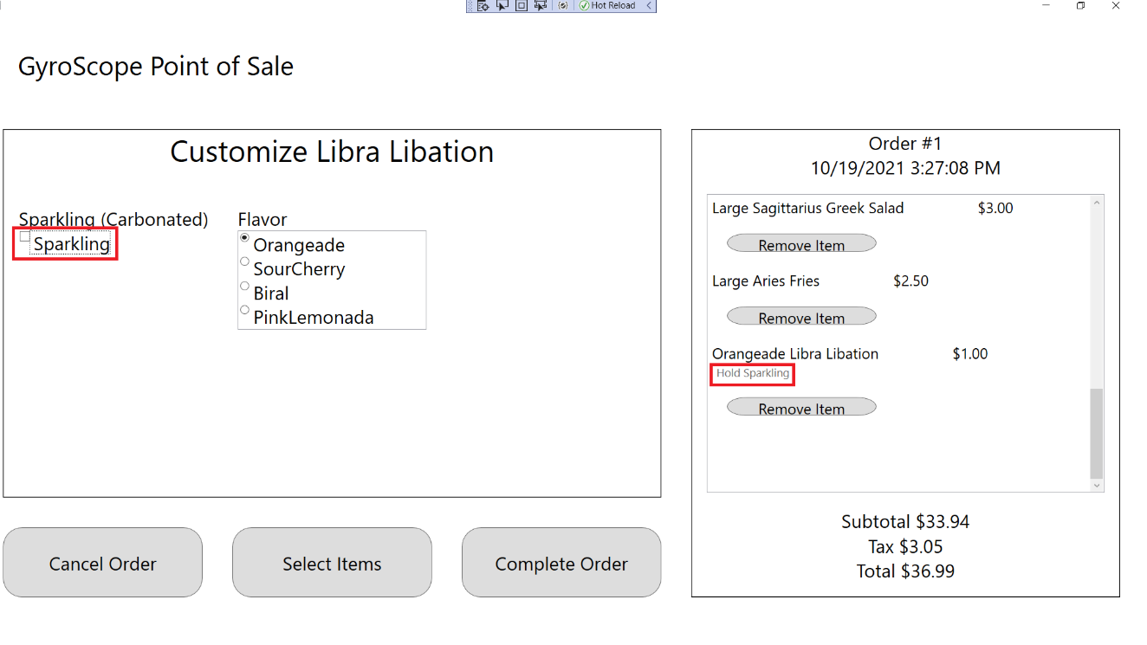

1. Select each Flavor one by one. The name of the menu item should change for each flavor.

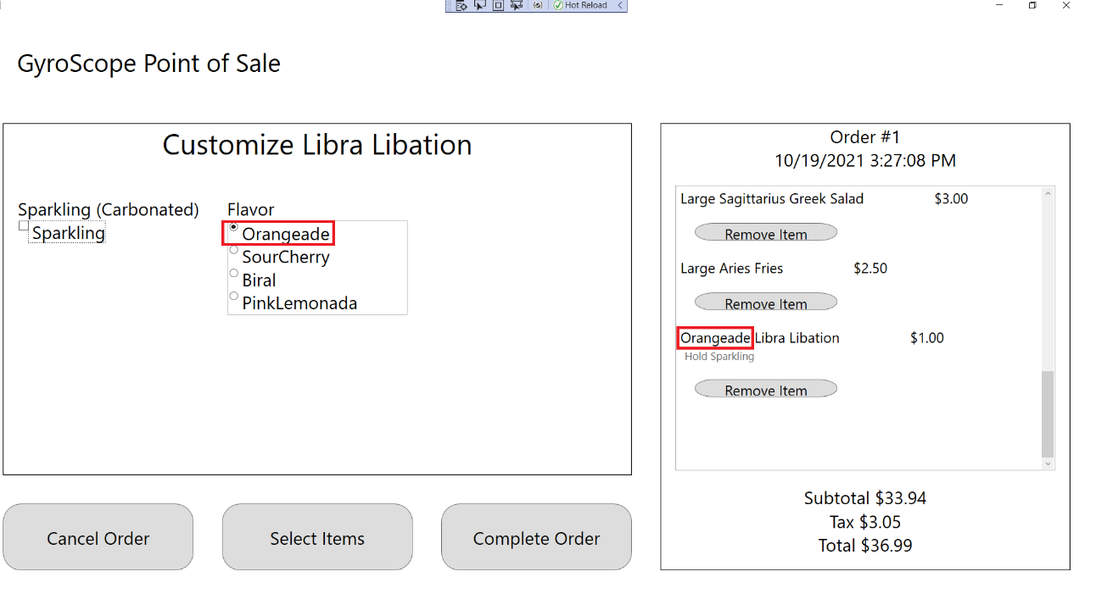

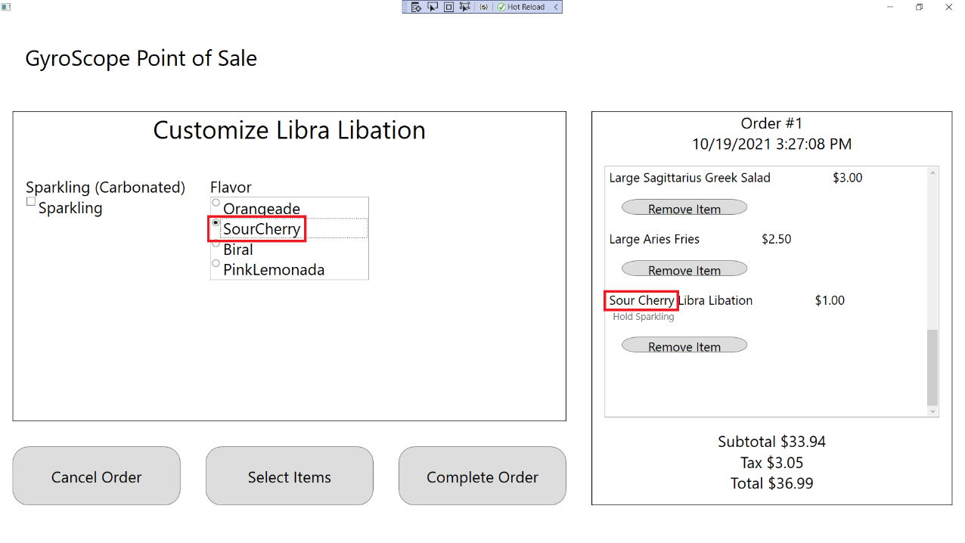

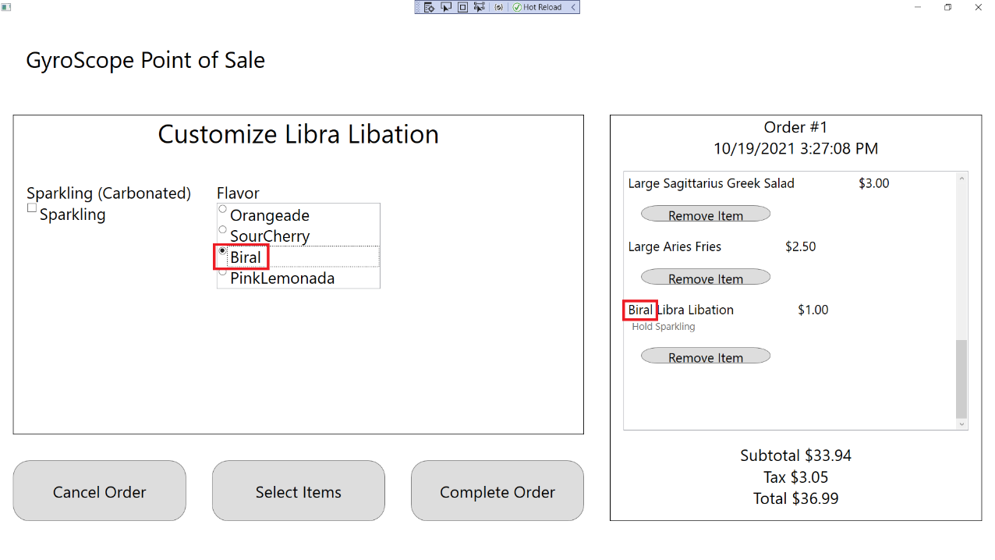

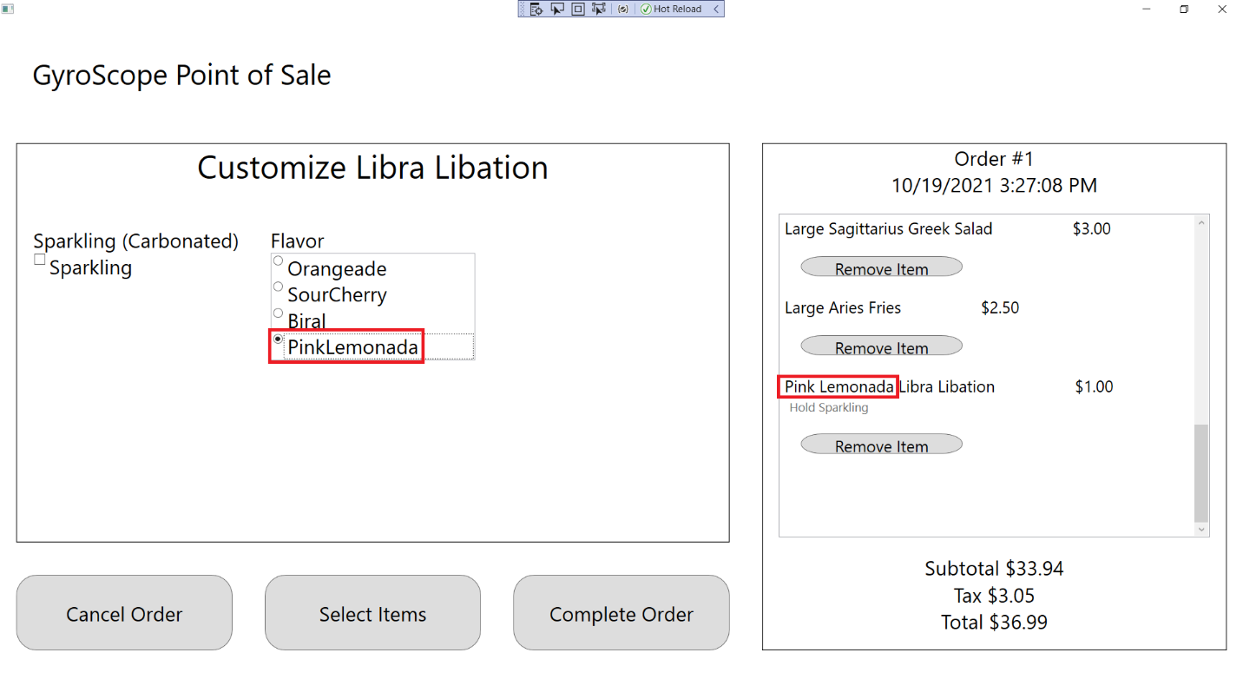

1. Press the “Select Items” button to return to the Menu Item Selection screen:

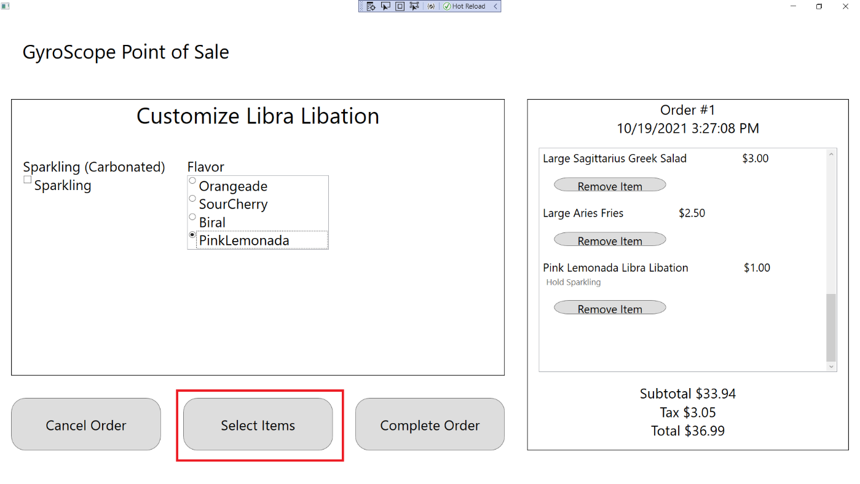

## Test #10 Adding and Customizing CapricornMountainTea

1. Click on Capricorn Mountain Tea

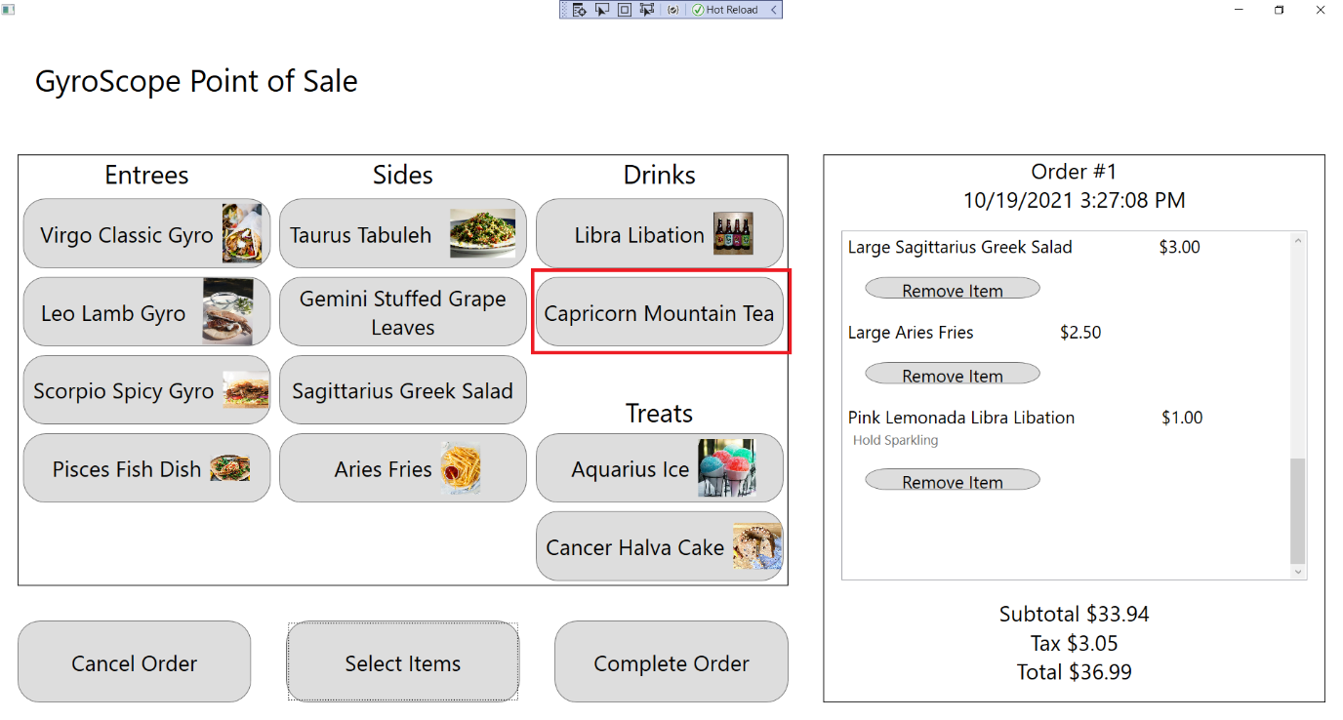

1. The customization screen should appear and a Capricorn Mountain Tea should be added to the order, with Order #1, $2.50 Price, $36.44 Subtotal, $3.28 Tax and $39.72 Total being displayed:

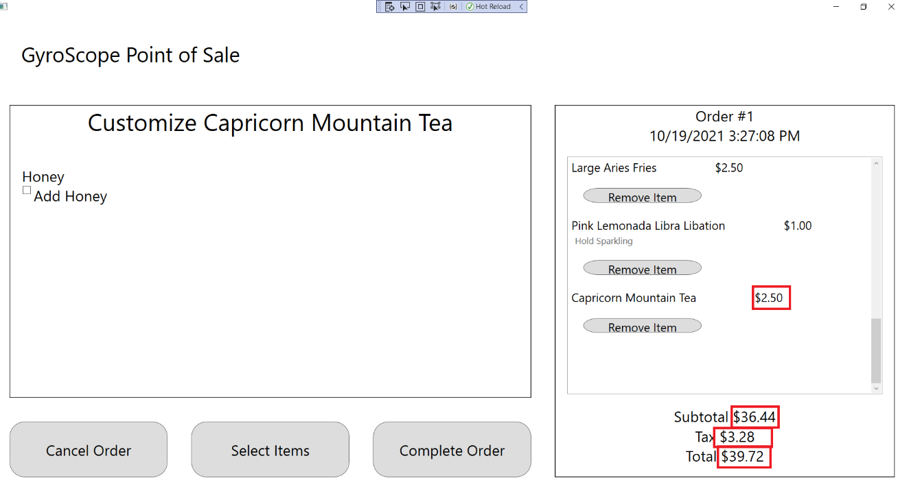

1. Check the Honey box. “Add Honey” should appear below the menu item:

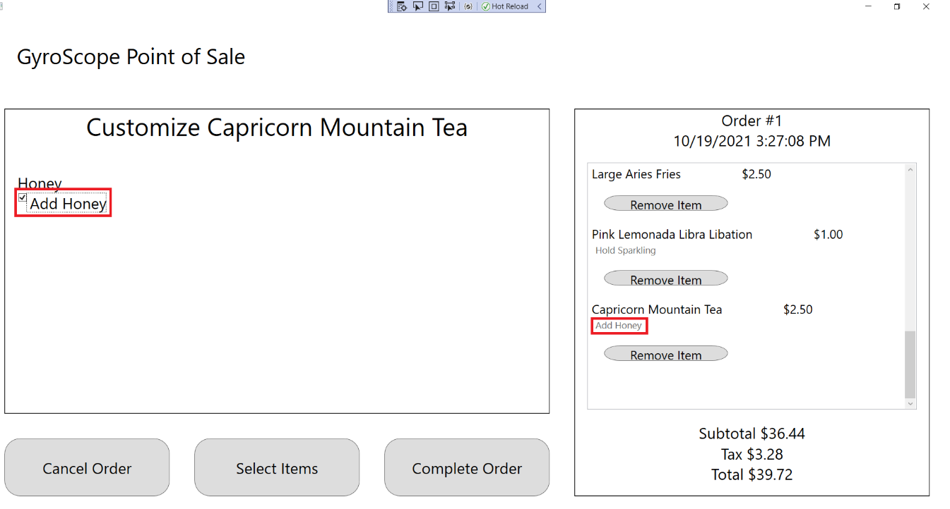

1. Click the “Select Items” button to return to the Menu Item Selection screen:

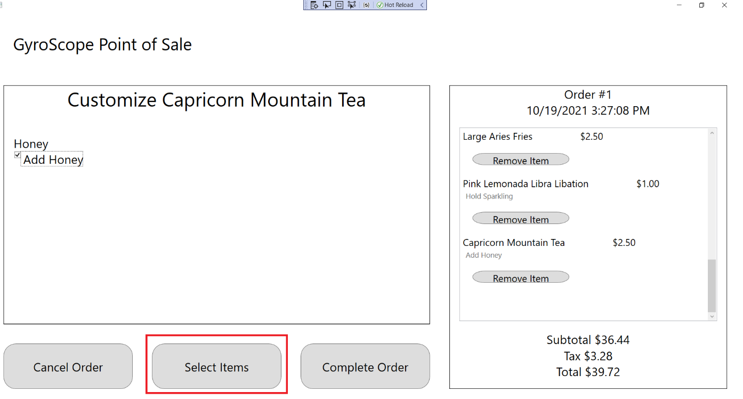

## Test #11 Adding and Customizing AquariusIce

1. Click on Aquarius Ice:

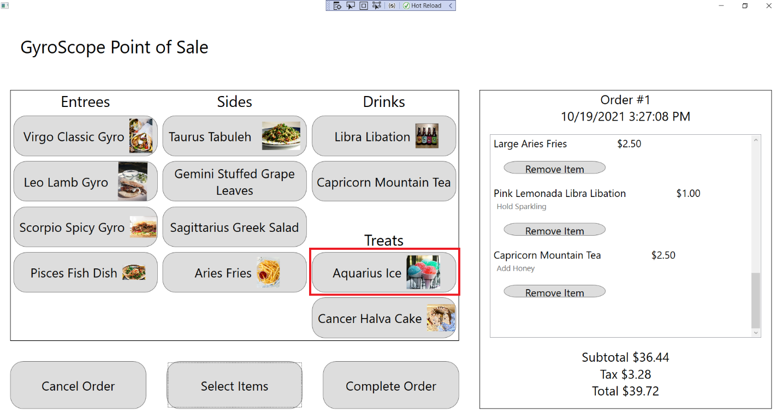

1. The customization screen should appear and an Aquarius Ice should be added to the order, with Order #1, $2.00 Price, $38.44 Subtotal, $3.46 Tax and $41.90 Total being displayed:

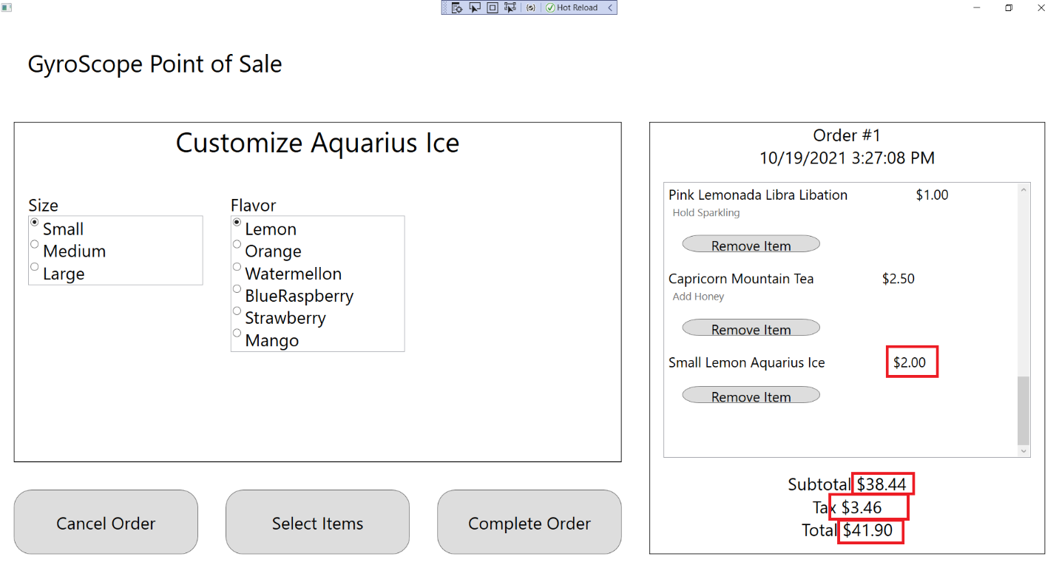

1. Change Size to Small, Medium, and Large. “Small”, “Medium, or “Large” should appear in front the Menu Item name, along with “$2.00”, $2.50”, and “$3.00”:

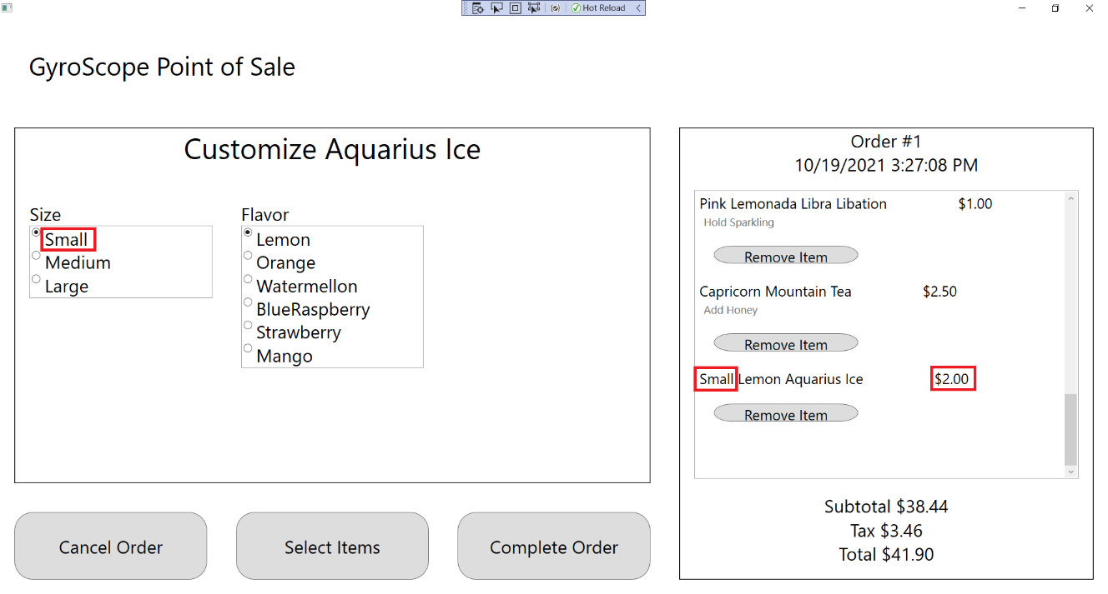

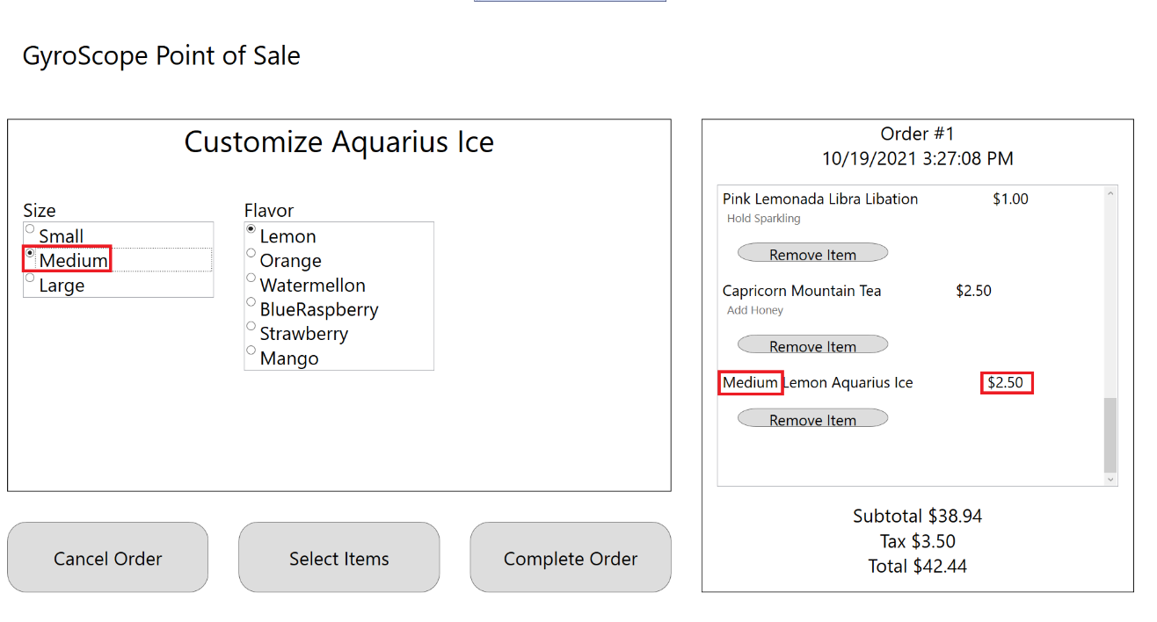

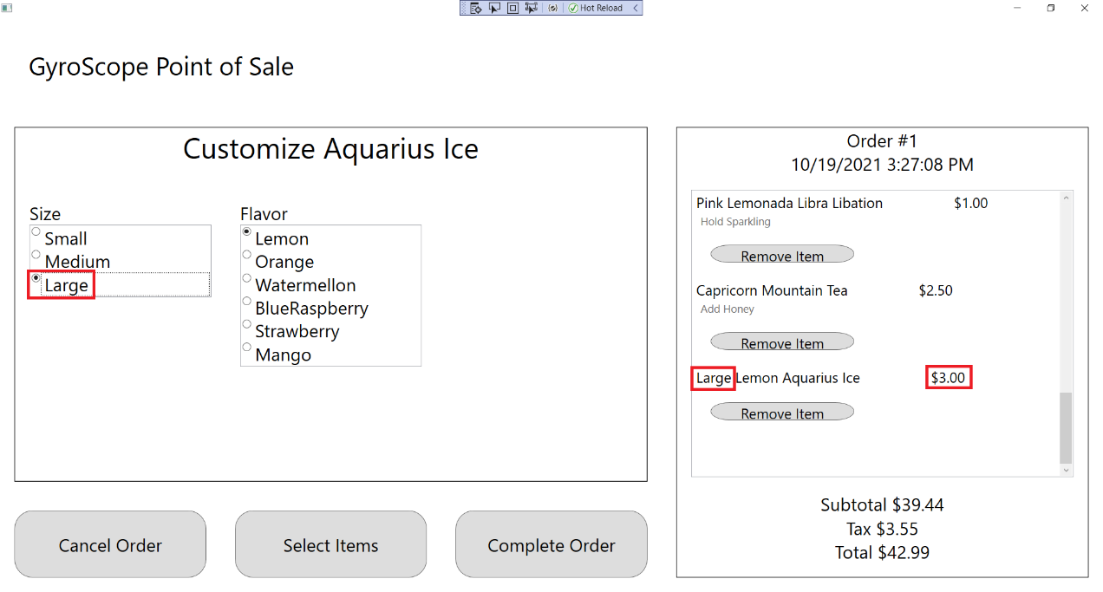

1. Click on each Flavor. The name of the Aquarius Ice should change:

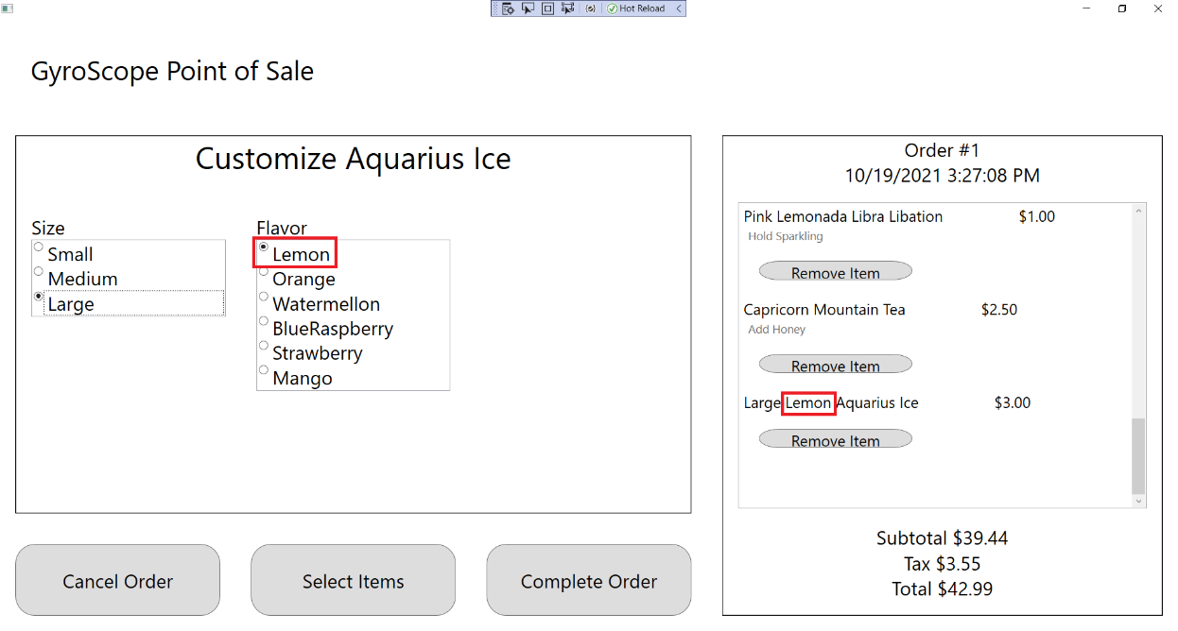

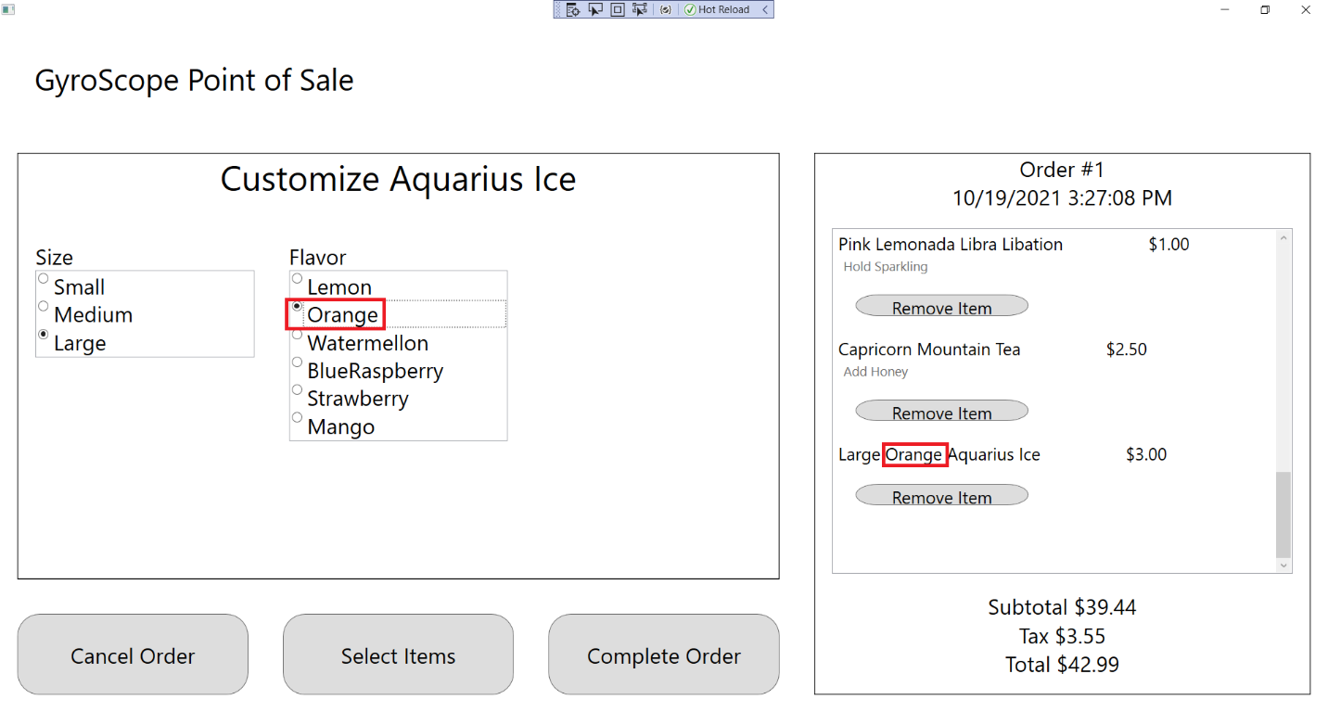

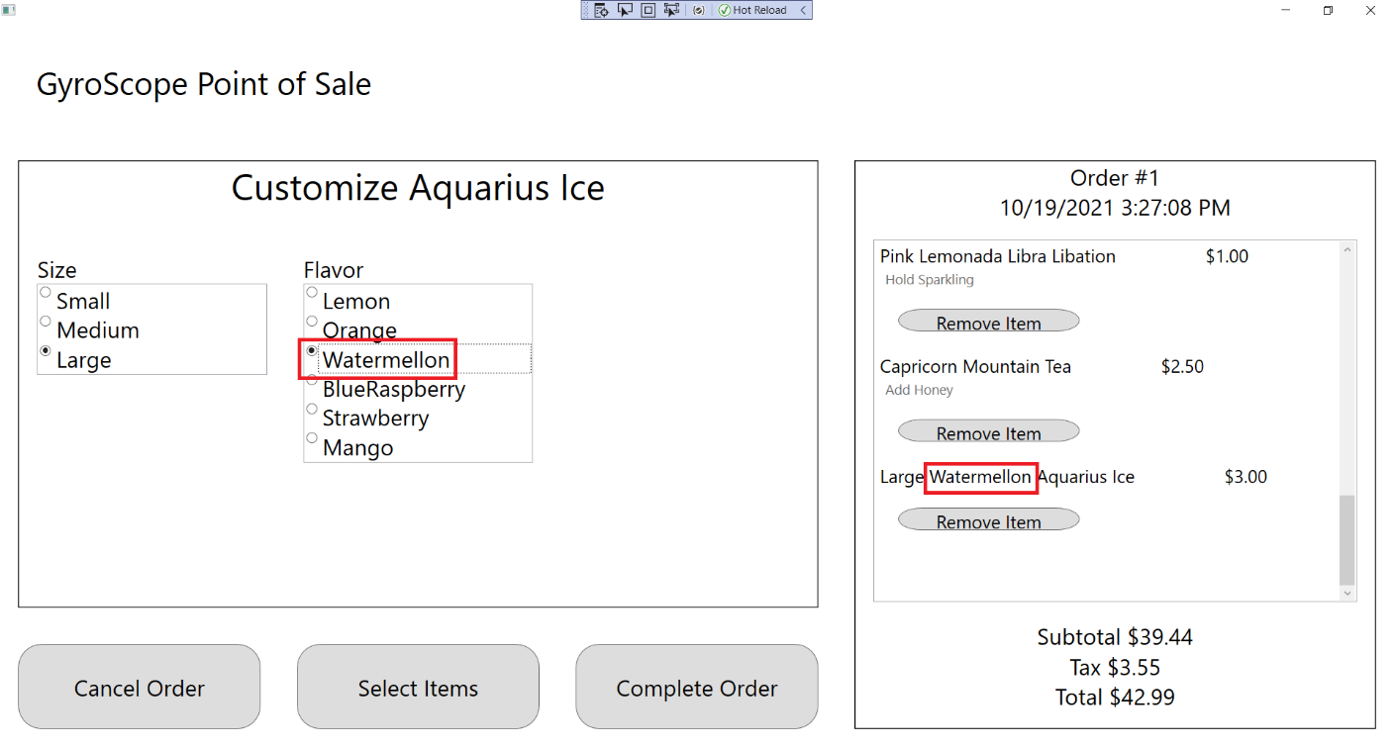

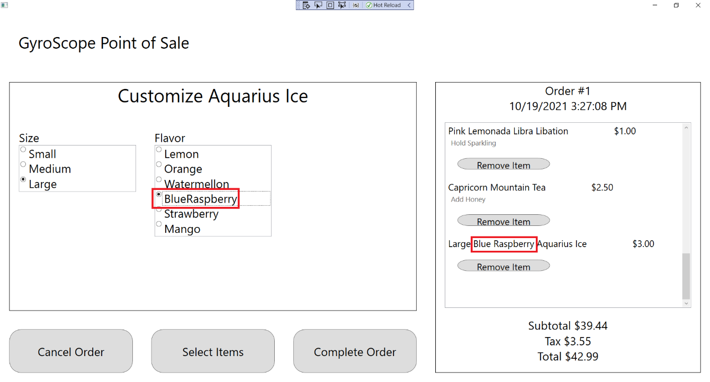

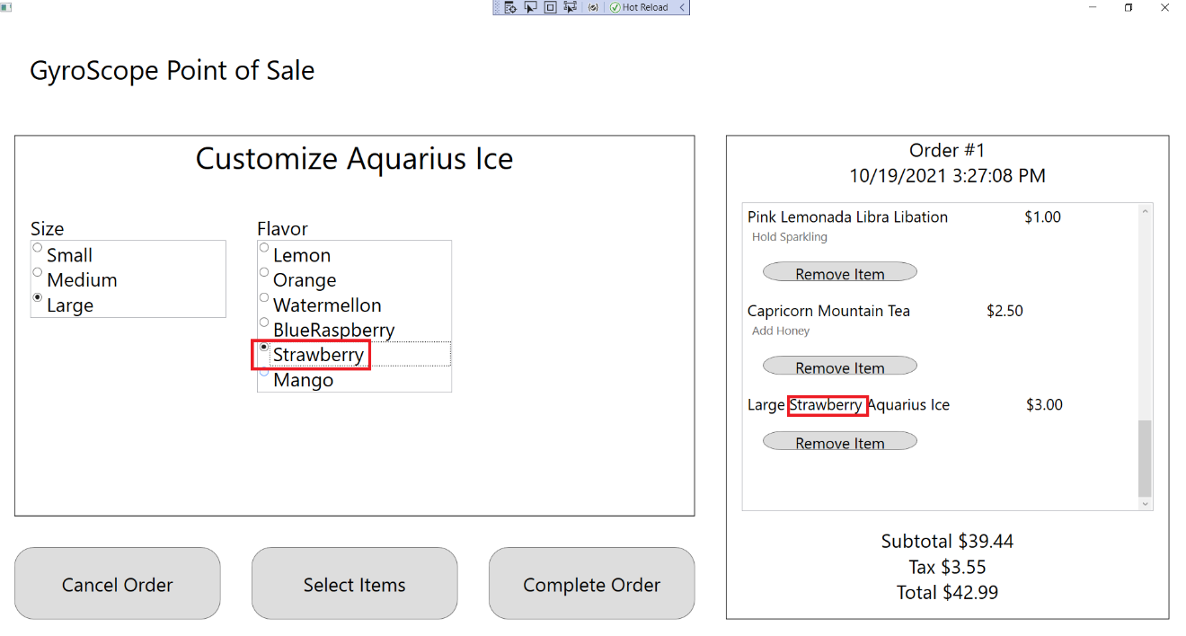

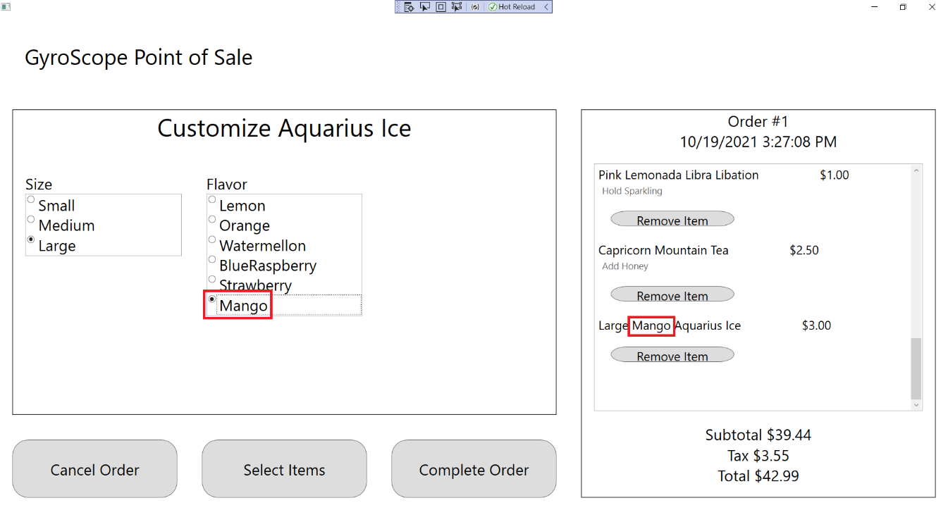

1. Click on the “Select Items” button to return to the Item Selection Menu:

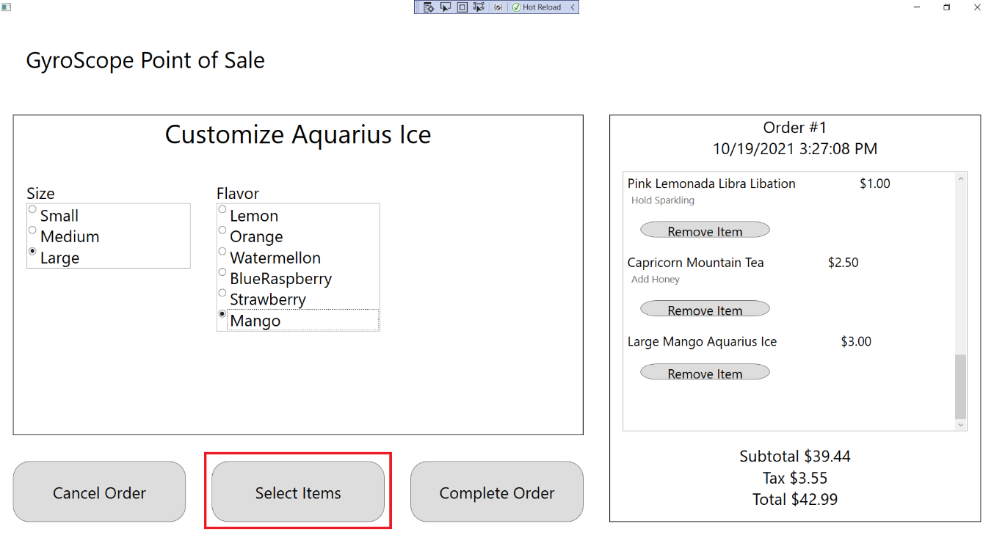

## Test #12 Adding and Customizing CancerHalvaCake

1. Click on Cancer Halva Cake:

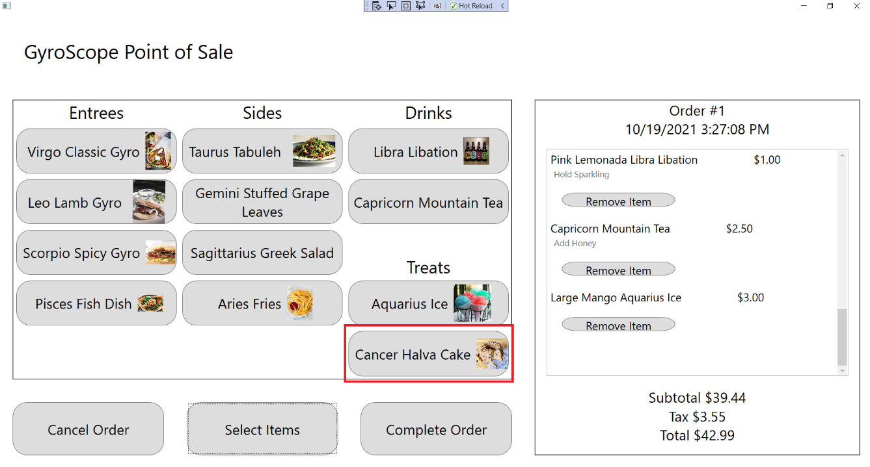

1. The customization screen should appear with a message saying that Cancer Halva Cake cannot be customized. A Cancer Halva Cake should be added to the order, with Order #1, $3.00 Price, $42.44 Subtotal, $3.82 Tax and $46.26 Total being displayed:

